As filed with the Securities and Exchange Commission on August 27, 2026
Registration No. 333-
UNITED STATES
SECURITIES AND EXCHANGE COMMISSION
Washington, D.C. 20549
_________________
FORM S-8
REGISTRATION STATEMENT
UNDER
THE SECURITIES ACT OF 1933
_________________
Affirm Holdings, Inc.
(Exact name of registrant as specified in its charter)
Nevada |  |  |  |  |  | 84-2224323
(State or other jurisdiction of  Incorporation or Organization) |  |  |  |  |  | (I.R.S. Employer  Identification No.)
221 Main Street, Floor 6
San Francisco, CA 94105
(415) 960-1518
(Address of principal executive offices) (Zip code)
_________________
Affirm Holdings, Inc. Amended and Restated 2012 Stock Plan
Affirm Holdings, Inc. 2020 Employee Stock Purchase Plan
(Full titles of the plans)
Max Levchin
Chief Executive Officer
221 Main Street, Floor 6
San Francisco, CA 94105
(415) 960-1518
(Name and address of agent for service) (Telephone number, including area code, of agent for service)
_________________
Copies to:

Katherine Adkins
Chief Legal Officer
221 Main Street, Floor 6
San Francisco, CA 94105
(415) 960-1518

Sean Feller
Gibson, Dunn & Crutcher LLP
2000 Avenue of the Stars, Suite 1200
Los Angeles, CA 90067-4700
(310) 552-8500
Indicate by check mark whether the registrant is a large accelerated filer, an accelerated filer, a non-accelerated filer, a smaller reporting company, or an emerging growth company. See the definitions of “large accelerated filer,” “accelerated filer,” “smaller reporting company” and “emerging growth company” in Rule 12b-2 of the Exchange Act.
Large accelerated filer |  |  |  |  |  | ☒ |  |  |  |  |  | Accelerated filer |  |  |  |  |  | ☐
Non-accelerated filer |  |  |  |  |  | ☐ |  |  |  |  |  | Smaller reporting company |  |  |  |  |  | ☐
 |  |  |  |  |  |  |  |  |  |  |  | Emerging growth company |  |  |  |  |  | ☐
If an emerging growth company, indicate by check mark if the registrant has elected not to use the extended transition period for complying with any new or revised financial accounting standards provided pursuant to Section 7(a)(2)(B) of the Securities Act. ☐

REGISTRATION OF ADDITIONAL SHARES
PURSUANT TO GENERAL INSTRUCTION E

Pursuant to General Instruction E of Form S-8, Affirm Holdings, Inc., a Nevada corporation (the “Registrant”), is filing this registration statement on Form S-8 (this “Registration Statement”) with the Securities and Exchange Commission (the “Commission”) to register 16,858,785 additional shares of its Class A common stock, par value $0.00001 per share (“Common Stock”), under the Affirm Holdings, Inc. Amended and Restated 2012 Stock Plan (the “2012 Stock Plan”) and 3,371,757 additional shares of Common Stock under the Affirm Holdings, Inc. 2020 Employee Stock Purchase Plan (the “ESPP,” and together with the 2012 Stock Plan, the “Plans”) pursuant to the respective provisions of the Plans providing for an automatic annual increase in the number of shares of Common Stock reserved for issuance under the Plans. This Registration Statement hereby incorporates by reference the contents of the Registrant’s previous registration statements on Form S-8 filed with the Commission on January 13, 2021 (Registration No. 333-252068), February 2, 2021 (Registration No. 333-252644), September 17, 2021 (Registration No. 333-259614), August 29, 2022 (Registration No. 333-267141), August 25, 2023 (Registration No. 333-274219), August 28, 2024 (Registration No. 333-281828), and August 28, 2025 (Registration No. 333-289923). In accordance with the instructional note of Part I of Form S-8 as promulgated by the Commission, the information specified by Part I of Form S-8 has been omitted from this Registration Statement.

PART II

INFORMATION REQUIRED IN THE REGISTRATION STATEMENT

Item 8. |  |  |  |  |  | Exhibits
Exhibit  Number |  |  |  |  |  | Description
4.1(1) |  |  |  |  |  | Articles of Incorporation
4.2(2) |  |  |  |  |  | Bylaws
5.1* |  |  |  |  |  | Opinion of Brownstein Hyatt Farber Schreck, LLP
23.1* |  |  |  |  |  | Consent of Brownstein Hyatt Farber Schreck, LLP (included in Exhibit 5.1)
23.2* |  |  |  |  |  | Consent of Deloitte & Touche LLP, independent registered public accountant
24.1* |  |  |  |  |  | Power of Attorney (included on the signature page of this Registration Statement)
99.1(3) |  |  |  |  |  | Amended and Restated 2012 Stock Plan
99.2(4) |  |  |  |  |  | 2020 Employee Stock Purchase Plan
107.1* |  |  |  |  |  | Filing Fee Table
(1)Incorporated by reference to Exhibit 3.1 filed with the Registrant’s Current Report on Form 8-K, filed with the Commission on June 26, 2025.
(2)Incorporated by reference to Exhibit 3.2 filed with the Registrant’s Current Report on Form 8-K, filed with the Commission on June 26, 2025.
(3)Incorporated by reference to Exhibit 10.3 filed with the Registrant’s Quarterly Report on Form 10-Q for the fiscal quarter ended December 31, 2022, filed with the Commission on February 8, 2023.
(4)Incorporated by reference to Exhibit 10.3 filed with the Registrant’s Registration Statement on Form S-1/A, filed with the Commission on November 20, 2020.

*Filed herewith

SIGNATURES
Pursuant to the requirements of the Securities Act of 1933, as amended (the “Securities Act”), the Registrant certifies that it has reasonable grounds to believe that it meets all of the requirements for filing on Form S-8 and has duly caused this Registration Statement to be signed on its behalf by the undersigned, thereunto duly authorized, in the City of San Francisco, State of California, on this 27th day of August, 2026.
AFFIRM HOLDINGS, INC.
By: |  |  |  |  |  | /s/ Max Levchin
 |  |  |  |  |  | Max Levchin
 |  |  |  |  |  | Chief Executive Officer

POWER OF ATTORNEY
The undersigned directors and officers of the Registrant hereby constitute and appoint Max Levchin, Rob O’Hare and Katherine Adkins, and each of them, any of whom may act without joinder of the other, the individual’s true and lawful attorneys-in-fact and agents, with full power of substitution and resubstitution, for the person and in his or her name, place and stead, in any and all capacities, to sign this Registration Statement and any or all amendments, including post-effective amendments to this Registration Statement, including any registration statement for the same offering that is to be effective upon filing pursuant to Rule 462 under the Securities Act, and all other documents in connection therewith to be filed with the Commission, granting unto said attorneys-in-fact and agents, and each of them, full power and authority to do and perform each and every act and thing requisite and necessary to be done in and about the premises, as fully to all intents and purposes as he or she might or could do in person, hereby ratifying and confirming all that said attorneys-in-fact as agents or any of them, or their substitute or substitutes, may lawfully do or cause to be done by virtue hereof.
Pursuant to the requirements of the Securities Act, this Registration Statement has been signed by the following persons in the capacities indicated on August 27, 2026.

Signature |  |  | Capacity
/s/ Max Levchin
Max Levchin |  |  | Chairman of the Board of Directors and Chief Executive Officer  (principal executive officer)
/s/ Rob O’Hare
Rob O’Hare |  |  | Chief Financial Officer (principal financial officer)
/s/ Siphelele Jiyane
Siphelele Jiyane |  |  | Chief Accounting Officer (principal accounting officer)
/s/ Richard Galanti
Richard Galanti |  |  | Director
/s/ Brian D. Hughes
Brian D. Hughes |  |  | Director
/s/ Jeremy Liew
Jeremy Liew |  |  | Director
/s/ Libor Michalek
Libor Michalek |  |  | President and Director
/s/ Christa S. Quarles
Christa S. Quarles |  |  | Director
/s/ Jacqueline D. Reses
Jacqueline D. Reses |  |  | Director
/s/ Manolo Sanchez
Manolo Sanchez |  |  | Director
/s/ Ryan Schneider
Ryan Schneider |  |  | Director
/s/ Noel Watson
Noel Watson |  |  | Director

Calculation of Filing Fee Tables
S-8
Affirm Holdings, Inc.
Table 1: Newly Registered Securities
 | Security Type | Security Class Title | Fee Calculation Rule | Amount Registered | Proposed Maximum Offering Price Per Unit | Maximum Aggregate Offering Price | Fee Rate | Amount of Registration Fee
1 | Equity | Class A Common Stock, par value $0.00001 per share | 457(a) | 16,858,785 | $ 75.05 | $ 1,265,251,814.25 | 0.0001381 | $ 174,731.28
2 | Equity | Class A Common Stock, par value $0.00001 per share | 457(a) | 3,371,757 | $ 64.62 | $ 217,882,937.34 | 0.0001381 | $ 30,089.63
Total Offering Amounts: |  |  |  |  |  | $ 1,483,134,751.59 |  | $ 204,820.91
Total Fee Offsets: |  |  |  |  |  |  |  | $ 0.00
Net Fee Due: |  |  |  |  |  |  |  | $ 204,820.91
Offering Note
1 | Amount Registered (applies to Offering Lines 1 and 2): Pursuant to Rule 416(a) promulgated under the Securities Act of 1933, as amended (the Securities Act), this Registration Statement on Form S-8 shall also cover any additional shares of Affirm Holdings, Inc. Class A common stock, $0.00001 par value per share (the Common Stock), that become issuable under the Affirm Holdings, Inc. Amended and Restated 2012 Stock Plan (the 2012 Stock Plan) and the Affirm Holdings, Inc. 2020 Employee Stock Purchase Plan (the 2020 ESPP) by reason of any stock dividend, stock split, recapitalization, or other similar transaction effected that results in an increase to the number of outstanding shares of Common Stock, as applicable. Represents 16,858,785 additional shares of Common Stock available for future issuance under the 2012 Stock Plan resulting from the automatic annual increase in the number of authorized shares of Common Stock reserved and available for issuance under the 2012 Stock Plan. The Proposed Maximum Offering Price Per Unit and the Maximum Aggregate Offering Price are estimated in accordance with Rules 457(c) and 457(h) under the Securities Act solely for the purpose of calculating the registration fee, based on the average of the high and low sales prices per share of Common Stock as reported on The Nasdaq Global Select Market on August 20, 2026 of $75.05 per share.
2 | Represents 3,371,757 additional shares of Common Stock reserved for future issuance under the 2020 ESPP resulting from the automatic annual increase in the number of authorized shares of Common Stock reserved and available for issuance under the 2020 ESPP. The Proposed Maximum Offering Price Per Unit and the Maximum Aggregate Offering Price are estimated in accordance with Rules 457(c) and 457(h) under the Securities Act solely for the purpose of calculating the registration fee, based on 85% of the average of the high and low sales prices per share of Common Stock as reported on Nasdaq on August 20, 2026 of $64.62 per share. Pursuant to the 2020 ESPP, the purchase price of a share of Common Stock is 85% of the fair market value of the Common Stock.
Table 2: Fee Offset Claims and Sources | ☑Not Applicable
 |  | Registrant or Filer Name | Form or Filing Type | File Number | Initial Filing Date | Filing Date | Fee Offset Claimed | Security Type Associated with Fee Offset Claimed | Security Title Associated with Fee Offset Claimed | Unsold Securities Associated with Fee Offset Claimed | Unsold Aggregate Offering Amount Associated with Fee Offset Claimed | Fee Paid with Fee Offset Source
Rule 457(p)
Fee Offset Claims
Fee Offset Sources
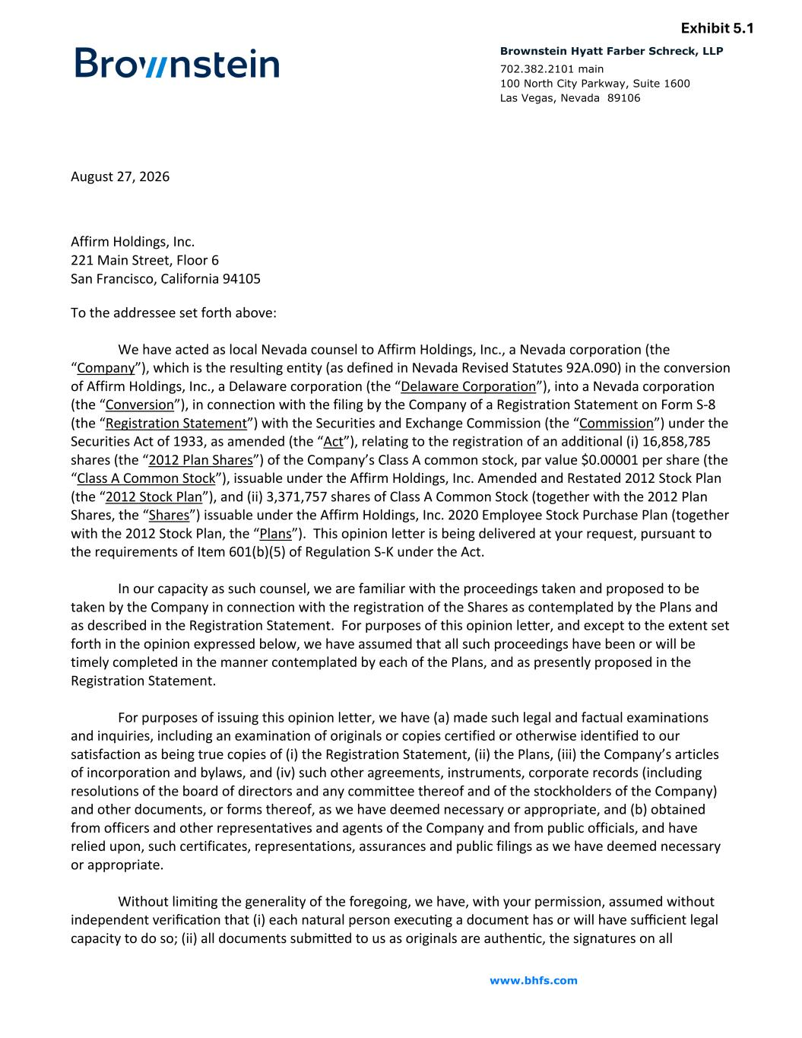
www.bhfs.com 702.382.2101 main 100 North City Parkway, Suite 1600 Las Vegas, Nevada 89106 Brownstein Hyatt Farber Schreck, LLP Exhibit 5.1 August 27, 2026 Affirm Holdings, Inc. 221 Main Street, Floor 6 San Francisco, California 94105 To the addressee set forth above: We have acted as local Nevada counsel to Affirm Holdings, Inc., a Nevada corporation (the “Company”), which is the resulting entity (as defined in Nevada Revised Statutes 92A.090) in the conversion of Affirm Holdings, Inc., a Delaware corporation (the “Delaware Corporation”), into a Nevada corporation (the “Conversion”), in connection with the filing by the Company of a Registration Statement on Form S-8 (the “Registration Statement”) with the Securities and Exchange Commission (the “Commission”) under the Securities Act of 1933, as amended (the “Act”), relating to the registration of an additional (i) 16,858,785 shares (the “2012 Plan Shares”) of the Company’s Class A common stock, par value $0.00001 per share (the “Class A Common Stock”), issuable under the Affirm Holdings, Inc. Amended and Restated 2012 Stock Plan (the “2012 Stock Plan”), and (ii) 3,371,757 shares of Class A Common Stock (together with the 2012 Plan Shares, the “Shares”) issuable under the Affirm Holdings, Inc. 2020 Employee Stock Purchase Plan (together with the 2012 Stock Plan, the “Plans”). This opinion letter is being delivered at your request, pursuant to the requirements of Item 601(b)(5) of Regulation S-K under the Act. In our capacity as such counsel, we are familiar with the proceedings taken and proposed to be taken by the Company in connection with the registration of the Shares as contemplated by the Plans and as described in the Registration Statement. For purposes of this opinion letter, and except to the extent set forth in the opinion expressed below, we have assumed that all such proceedings have been or will be timely completed in the manner contemplated by each of the Plans, and as presently proposed in the Registration Statement. For purposes of issuing this opinion letter, we have (a) made such legal and factual examinations and inquiries, including an examination of originals or copies certified or otherwise identified to our satisfaction as being true copies of (i) the Registration Statement, (ii) the Plans, (iii) the Company’s articles of incorporation and bylaws, and (iv) such other agreements, instruments, corporate records (including resolutions of the board of directors and any committee thereof and of the stockholders of the Company) and other documents, or forms thereof, as we have deemed necessary or appropriate, and (b) obtained from officers and other representatives and agents of the Company and from public officials, and have relied upon, such certificates, representations, assurances and public filings as we have deemed necessary or appropriate. Without limi]ng the generality of the foregoing, we have, with your permission, assumed without independent verifica]on that (i) each natural person execu]ng a document has or will have sufficient legal capacity to do so; (ii) all documents submiaed to us as originals are authen]c, the signatures on all

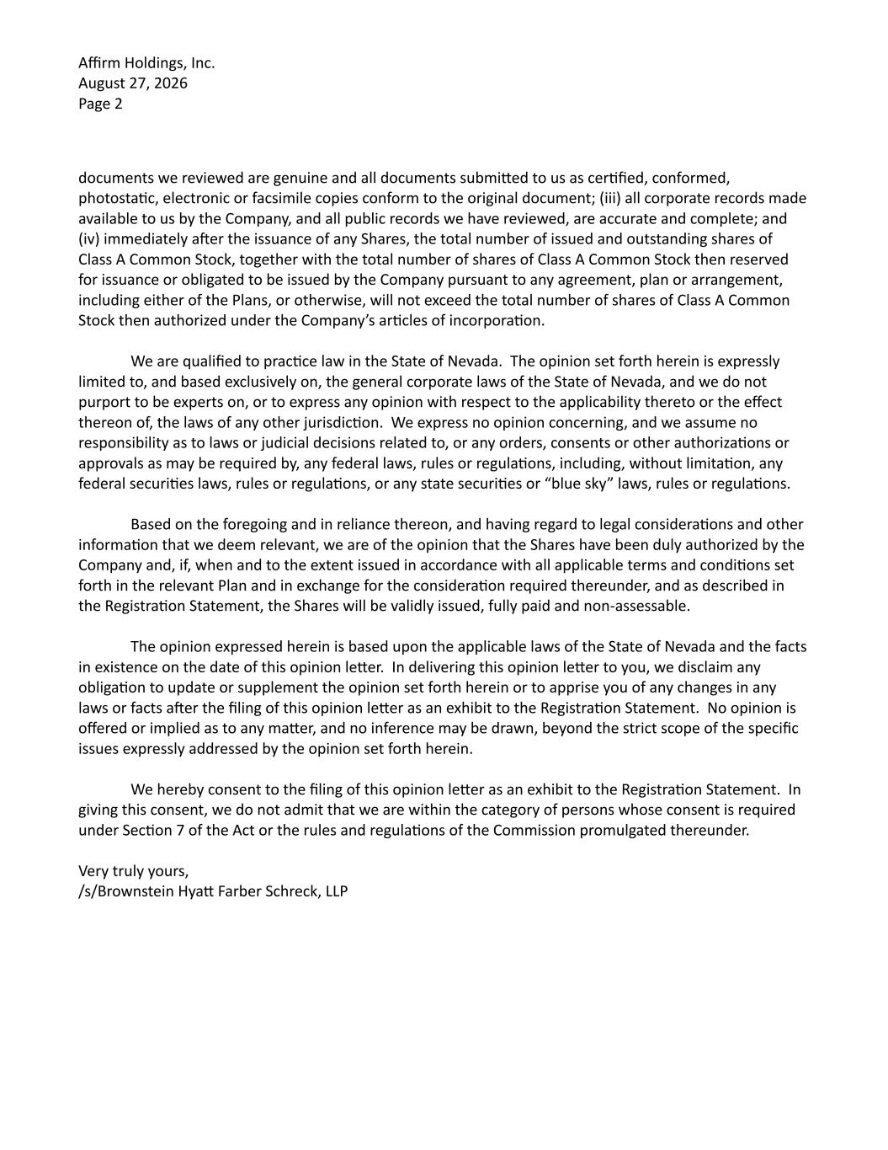
Affirm Holdings, Inc. August 27, 2026 Page 2 documents we reviewed are genuine and all documents submiaed to us as cer]fied, conformed, photosta]c, electronic or facsimile copies conform to the original document; (iii) all corporate records made available to us by the Company, and all public records we have reviewed, are accurate and complete; and (iv) immediately aber the issuance of any Shares, the total number of issued and outstanding shares of Class A Common Stock, together with the total number of shares of Class A Common Stock then reserved for issuance or obligated to be issued by the Company pursuant to any agreement, plan or arrangement, including either of the Plans, or otherwise, will not exceed the total number of shares of Class A Common Stock then authorized under the Company’s ar]cles of incorpora]on. We are qualified to prac]ce law in the State of Nevada. The opinion set forth herein is expressly limited to, and based exclusively on, the general corporate laws of the State of Nevada, and we do not purport to be experts on, or to express any opinion with respect to the applicability thereto or the effect thereon of, the laws of any other jurisdic]on. We express no opinion concerning, and we assume no responsibility as to laws or judicial decisions related to, or any orders, consents or other authoriza]ons or approvals as may be required by, any federal laws, rules or regula]ons, including, without limita]on, any federal securi]es laws, rules or regula]ons, or any state securi]es or “blue sky” laws, rules or regula]ons. Based on the foregoing and in reliance thereon, and having regard to legal considera]ons and other informa]on that we deem relevant, we are of the opinion that the Shares have been duly authorized by the Company and, if, when and to the extent issued in accordance with all applicable terms and condi]ons set forth in the relevant Plan and in exchange for the considera]on required thereunder, and as described in the Registra]on Statement, the Shares will be validly issued, fully paid and non-assessable. The opinion expressed herein is based upon the applicable laws of the State of Nevada and the facts in existence on the date of this opinion leaer. In delivering this opinion leaer to you, we disclaim any obliga]on to update or supplement the opinion set forth herein or to apprise you of any changes in any laws or facts aber the filing of this opinion leaer as an exhibit to the Registra]on Statement. No opinion is offered or implied as to any maaer, and no inference may be drawn, beyond the strict scope of the specific issues expressly addressed by the opinion set forth herein. We hereby consent to the filing of this opinion leaer as an exhibit to the Registra]on Statement. In giving this consent, we do not admit that we are within the category of persons whose consent is required under Sec]on 7 of the Act or the rules and regula]ons of the Commission promulgated thereunder. Very truly yours, /s/Brownstein Hyaa Farber Schreck, LLP

Exhibit 23.2
CONSENT OF INDEPENDENT REGISTERED PUBLIC ACCOUNTING FIRM

We consent to the incorporation by reference in this Registration Statement on Form S-8 of our reports dated August 27, 2026 relating to the financial statements of Affirm Holdings, Inc. and subsidiaries (the “Company”) and the effectiveness of the Company’s internal control over financial reporting, appearing in the Annual Report on Form 10-K of Affirm Holdings, Inc. for the year ended June 30, 2026.

/s/ Deloitte & Touche LLP

San Francisco, CA
August 27, 2026

