UNITED STATES
SECURITIES AND EXCHANGE COMMISSION
Washington, DC 20549
FORM 8-K
CURRENT REPORT
Pursuant to Section 13 or 15(d) of the
Securities Exchange Act of 1934
Date of report (Date of earliest event reported): May 7, 2026
Affirm Holdings, Inc.
(Exact name of registrant as specified in charter)
Nevada |  |  |  |  |  | 001-39888 |  |  |  |  |  | 84-2224323
(State or other jurisdiction  of incorporation) |  |  |  |  |  | (Commission  File Number) |  |  |  |  |  | (IRS Employer  Identification No.)

650 California Street
San Francisco, California |  |  |  |  |  | 94108
(Address of principal executive offices) |  |  |  |  |  | (Zip Code)

Registrant’s telephone number, including area code: (415) 960-1518
Not Applicable
(Former name or former address, if changed since last report)
Check the appropriate box below if the Form 8-K filing is intended to simultaneously satisfy the filing obligation of the registrant under any of the following provisions:
☐ Written communications pursuant to Rule 425 under the Securities Act (17 CFR 230.425)
☐ Soliciting material pursuant to Rule 14a-12 under the Exchange Act (17 CFR 240.14a-12)
☐ Pre-commencement communications pursuant to Rule 14d-2(b) under the Exchange Act (17 CFR 240.14d-2(b))
☐ Pre-commencement communications pursuant to Rule 13e-4(c) under the Exchange Act (17 CFR 240.13e-4(c))

Securities registered pursuant to Section 12(b) of the Act:
Title of each class: |  |  | Trading symbol(s) |  |  | Name of exchange on which registered
Class A common stock, $0.00001 par value |  |  | AFRM |  |  | Nasdaq Global Select Market
Indicate by check mark whether the registrant is an emerging growth company as defined in Rule 405 of the Securities Act of 1933 (§230.405 of this chapter) or Rule 12b-2 of the Securities Exchange Act of 1934 (§240.12b-2 of this chapter).
Emerging growth company ☐
If an emerging growth company, indicate by check mark if the registrant has elected not to use the extended transition period for complying with any new or revised financial accounting standards provided pursuant to Section 13(a) of the Exchange Act. ☐

Item 2.02. Results of Operations and Financial Condition.
On May 7, 2026, the Company issued a Shareholder Letter (the “Letter”) regarding its financial results for the third fiscal quarter ended March 31, 2026. A copy of the Letter is attached hereto as Exhibit 99.1, and the information in Exhibit 99.1 is incorporated herein by reference.
The Letter attached hereto as Exhibit 99.1 includes certain non-GAAP financial measures. Reconciliations of these non-GAAP financial measures to the comparable GAAP financial measures are contained in the Letter and the financial tables attached thereto.
The information in this Item 2.02 and in Exhibit 99.1 attached hereto shall not be deemed “filed” for the purposes of Section 18 of the Securities Exchange Act of 1934, as amended, or otherwise subject to the liabilities of that section, nor shall it be deemed incorporated by reference into any filing under the Securities Act of 1933, as amended.

Item 9.01. Financial Statements and Exhibits.

(d) Exhibits.
Exhibit No. |  |  | Description
99.1 |  |  | Shareholder Letter, dated May 7, 2026
104 |  |  | Cover Page Interactive Data File (embedded within the Inline XBRL document)

2

SIGNATURE
Pursuant to the requirements of the Securities Exchange Act of 1934, the registrant has duly caused this report to be signed on its behalf by the undersigned hereunto duly authorized.
 |  |  |  |  |  | AFFIRM HOLDINGS, INC.
 |  |  | By: |  |  | /s/ Rob O'Hare
 |  |  |  |  |  | Name: Rob O'Hare
 |  |  |  |  |  | Title: Chief Financial Officer

Date: May 7, 2026

3

Third Fiscal Quarter 2026

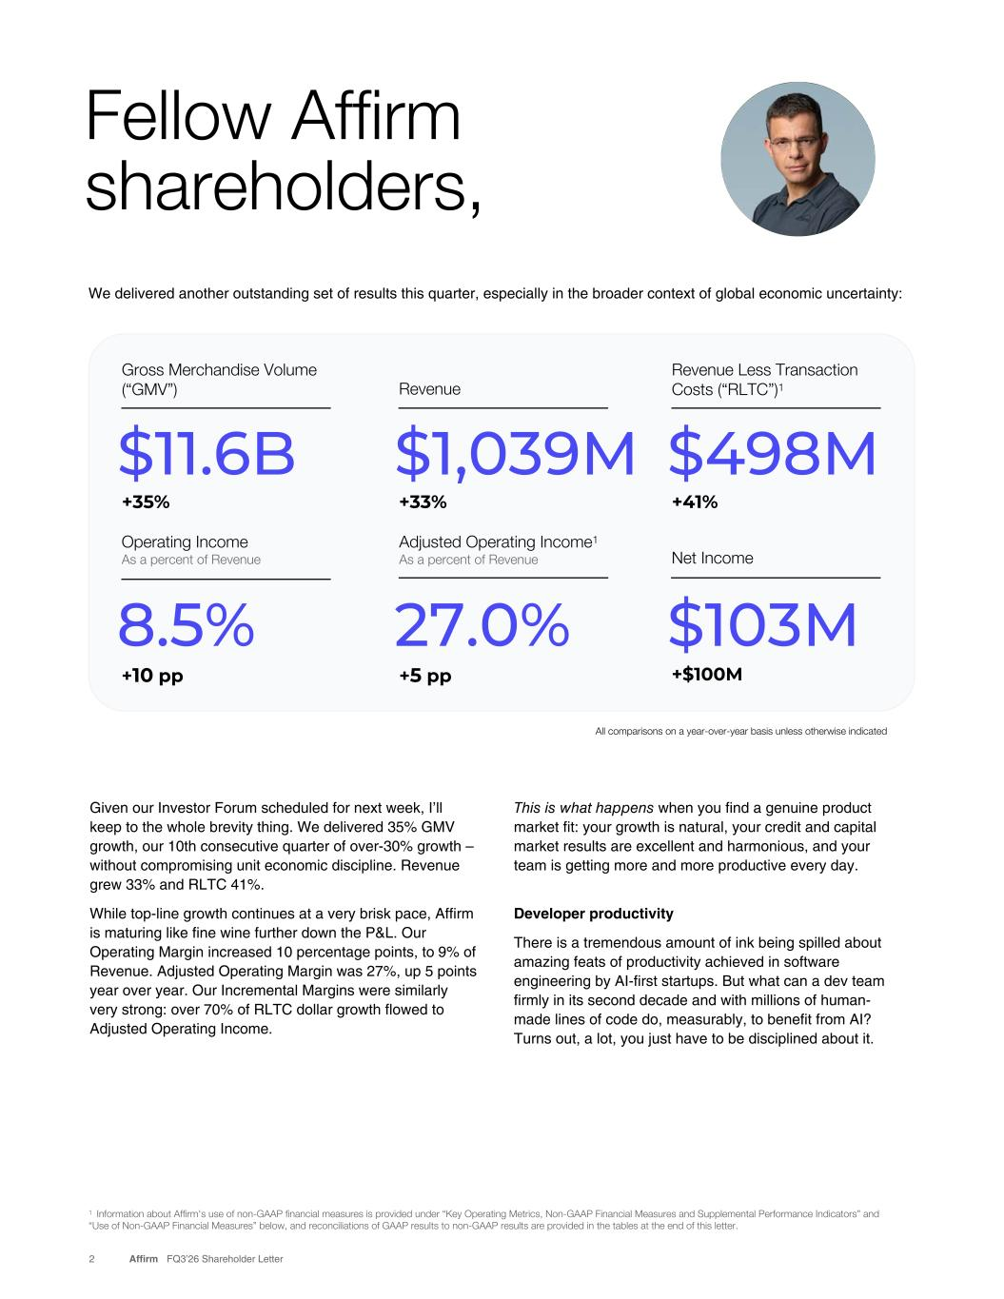
We delivered another outstanding set of results this quarter, especially in the broader context of global economic uncertainty: Fellow Affirm shareholders, 2 Affirm FQ3’26 Shareholder Letter 1 Information about Affirm's use of non-GAAP financial measures is provided under “Key Operating Metrics, Non-GAAP Financial Measures and Supplemental Performance Indicators” and “Use of Non-GAAP Financial Measures” below, and reconciliations of GAAP results to non-GAAP results are provided in the tables at the end of this letter. $498M Revenue Less Transaction Costs (“RLTC”)1 +41% $1,039M Revenue +33% $11.6B Gross Merchandise Volume (“GMV”) +35% Net Income +$100M 27.0% Adjusted Operating Income1 As a percent of Revenue +5 pp 8.5% Operating Income As a percent of Revenue +10 pp $103M Given our Investor Forum scheduled for next week, I’ll keep to the whole brevity thing. We delivered 35% GMV growth, our 10th consecutive quarter of over-30% growth – without compromising unit economic discipline. Revenue grew 33% and RLTC 41%. While top-line growth continues at a very brisk pace, Affirm is maturing like fine wine further down the P&L. Our Operating Margin increased 10 percentage points, to 9% of Revenue. Adjusted Operating Margin was 27%, up 5 points year over year. Our Incremental Margins were similarly very strong: over 70% of RLTC dollar growth flowed to Adjusted Operating Income. All comparisons on a year-over-year basis unless otherwise indicated This is what happens when you find a genuine product market fit: your growth is natural, your credit and capital market results are excellent and harmonious, and your team is getting more and more productive every day. Developer productivity There is a tremendous amount of ink being spilled about amazing feats of productivity achieved in software engineering by AI-first startups. But what can a dev team firmly in its second decade and with millions of human- made lines of code do, measurably, to benefit from AI? Turns out, a lot, you just have to be disciplined about it.


3 Affirm FQ3’26 Shareholder Letter Consumer health The Affirm consumer remains financially healthy. We see neither a change in demand nor in our consumers’ ability to repay. Delinquencies were up in line with expectations, with roughly half of the increase coming from a reduced denominator primarily due to stronger tax refund seasonality. Additionally, very strong unit economics (RLTC over 4.3% of GMV), gave us room to capture demand that delivered great returns – credit continues to be a setting we choose for our business. Zesty capital markets demand was a resounding vote of confidence in our approach to credit. We grew capacity despite the lower seasonal volume of our third fiscal quarter. We also priced our third consecutive revolving ABS transaction under a 5% blended yield in March, and our average annualized cost of funds reached the lowest level in three and a half years. Earlier this quarter we took a full week as a development team to re-tool Affirm software engineering to be truly AI- first. You can see the difference below, with agentically- written code dominating non-agentic essentially overnight after this effort. The chart shows pull requests per week (each pull request is a product feature, a major bug fix, etc) as a function of time. We think an order of magnitude gain in software development productivity is entirely plausible, yet we expect to modestly grow our development team – the limiting factor for Affirm has always been engineering cycles, not ideas for what to do with them. Pull requests (PRs) merged per week


4 Affirm FQ3’26 Shareholder Letter When asked at an all-hands Q&A a few weeks ago whether I thought Affirm was still a startup, I responded with an emphatic affirmative. There are plenty of risks and even more opportunities. We have all sorts of plans for very ambitious new initiatives (some of which will surely not work out), cutting-edge AI/ML research profoundly accretive to all parts of our business, and exciting upcoming partnerships. …and yet for all our compounding growth we are but a very small fraction of global commerce. Nearly 15 years in, we are still a tightly-knit crew of idealist pirates on a mission, trying to improve lives and having a lot of fun doing it. Thank you to all Affirmers for another great quarter, watching you execute is the great privilege of captaining this ship. I’ll see many of you in person next week. Onward, 2 ‘All Forms of Credit Are Not Created Equal’. Published by Affirm in June 2025. Lotta ins, lotta outs • We announced the next Big Nothing event, May 13-15. Stay tuned for great 0% APR offers from thousands of our merchant partners! • Truly excited to add Nordstrom and URBN to our merchant roster in the US. • Sleep Number is also a new addition, with 0% APR offers up to 12 months at launch. • We are ramping our partnerships with Lowe’s and Intuit, and are pleased with the early reads. • The Card continues to scale nicely, now with 4.4 million active Cardholders and $2.1 billion in Card GMV. • Let me go find a cash machine – we don’t brag enough about the cash flow Affirm is already generating. We added approximately $230 million to our net cash (now at $1.35 billion) since December, and $370 million in the last year.

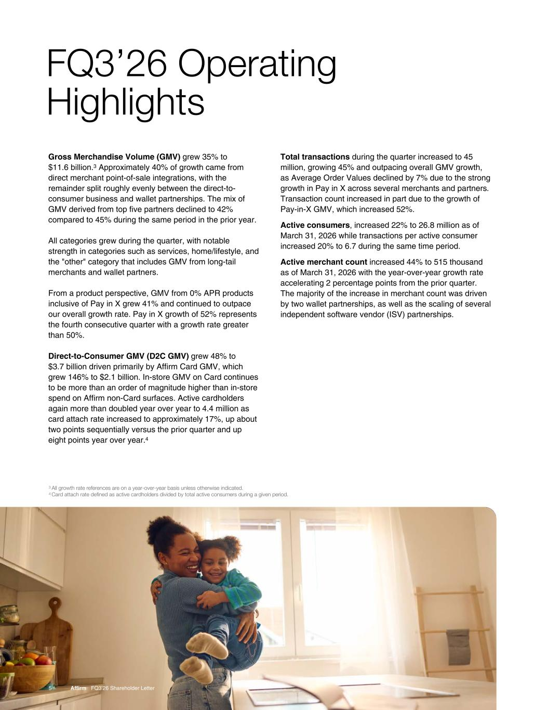
Gross Merchandise Volume (GMV) grew 35% to $11.6 billion.3 Approximately 40% of growth came from direct merchant point-of-sale integrations, with the remainder split roughly evenly between the direct-to- consumer business and wallet partnerships. The mix of GMV derived from top five partners declined to 42% compared to 45% during the same period in the prior year. All categories grew during the quarter, with notable strength in categories such as services, home/lifestyle, and the "other" category that includes GMV from long-tail merchants and wallet partners. From a product perspective, GMV from 0% APR products inclusive of Pay in X grew 41% and continued to outpace our overall growth rate. Pay in X growth of 52% represents the fourth consecutive quarter with a growth rate greater than 50%. Direct-to-Consumer GMV (D2C GMV) grew 48% to $3.7 billion driven primarily by Affirm Card GMV, which grew 146% to $2.1 billion. In-store GMV on Card continues to be more than an order of magnitude higher than in-store spend on Affirm non-Card surfaces. Active cardholders again more than doubled year over year to 4.4 million as card attach rate increased to approximately 17%, up about two points sequentially versus the prior quarter and up eight points year over year.4 FQ3’26 Operating Highlights 5 Affirm FQ3’26 Shareholder Letter Total transactions during the quarter increased to 45 million, growing 45% and outpacing overall GMV growth, as Average Order Values declined by 7% due to the strong growth in Pay in X across several merchants and partners. Transaction count increased in part due to the growth of Pay-in-X GMV, which increased 52%. Active consumers, increased 22% to 26.8 million as of March 31, 2026 while transactions per active consumer increased 20% to 6.7 during the same time period. Active merchant count increased 44% to 515 thousand as of March 31, 2026 with the year-over-year growth rate accelerating 2 percentage points from the prior quarter. The majority of the increase in merchant count was driven by two wallet partnerships, as well as the scaling of several independent software vendor (ISV) partnerships. 3 All growth rate references are on a year-over-year basis unless otherwise indicated. 4 Card attach rate defined as active cardholders divided by total active consumers during a given period.

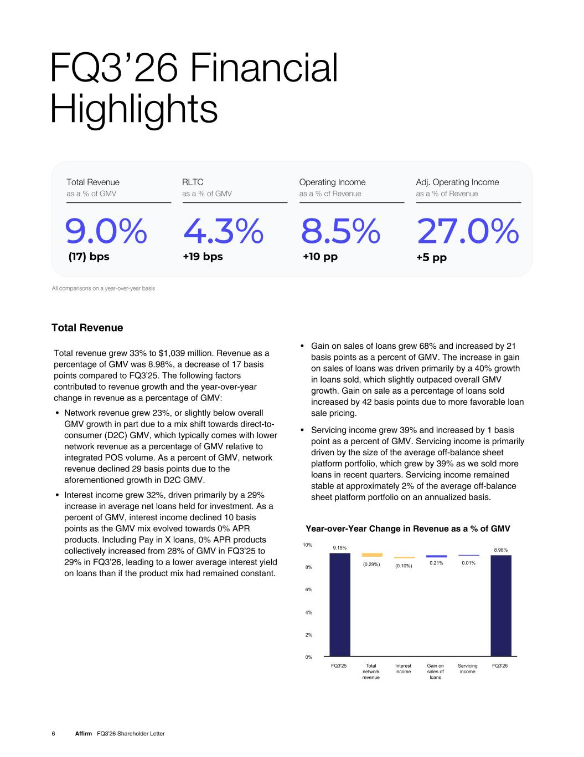
Total revenue grew 33% to $1,039 million. Revenue as a percentage of GMV was 8.98%, a decrease of 17 basis points compared to FQ3’25. The following factors contributed to revenue growth and the year-over-year change in revenue as a percentage of GMV: • Network revenue grew 23%, or slightly below overall GMV growth in part due to a mix shift towards direct-to- consumer (D2C) GMV, which typically comes with lower network revenue as a percentage of GMV relative to integrated POS volume. As a percent of GMV, network revenue declined 29 basis points due to the aforementioned growth in D2C GMV. • Interest income grew 32%, driven primarily by a 29% increase in average net loans held for investment. As a percent of GMV, interest income declined 10 basis points as the GMV mix evolved towards 0% APR products. Including Pay in X loans, 0% APR products collectively increased from 28% of GMV in FQ3’25 to 29% in FQ3’26, leading to a lower average interest yield on loans than if the product mix had remained constant. • Gain on sales of loans grew 68% and increased by 21 basis points as a percent of GMV. The increase in gain on sales of loans was driven primarily by a 40% growth in loans sold, which slightly outpaced overall GMV growth. Gain on sale as a percentage of loans sold increased by 42 basis points due to more favorable loan sale pricing. • Servicing income grew 39% and increased by 1 basis point as a percent of GMV. Servicing income is primarily driven by the size of the average off-balance sheet platform portfolio, which grew by 39% as we sold more loans in recent quarters. Servicing income remained stable at approximately 2% of the average off-balance sheet platform portfolio on an annualized basis. FQ3’26 Financial Highlights 6 Affirm FQ3’26 Shareholder Letter Total Revenue Adj. Operating Income as a % of Revenue 27% +4 pp Total Revenue as a % of GMV 9.0% RLTC as a % of GMV 4.3% +19 bps Operating Income as a % of Revenue 8.5% +10 pp All comparisons on a year-over-year basis (17) bps Adj. Operating Income as a % of Revenue .0% 5 Year-over-Year Change in Revenue as a % of GMV 9.15% (0.29%) (0.10%) 0.21% 0.01% 8.98% FQ3'25 Total network revenue Interest income Gain on sales of loans Servicing income FQ3'26 0% 2% 4% 6% 8% 10%

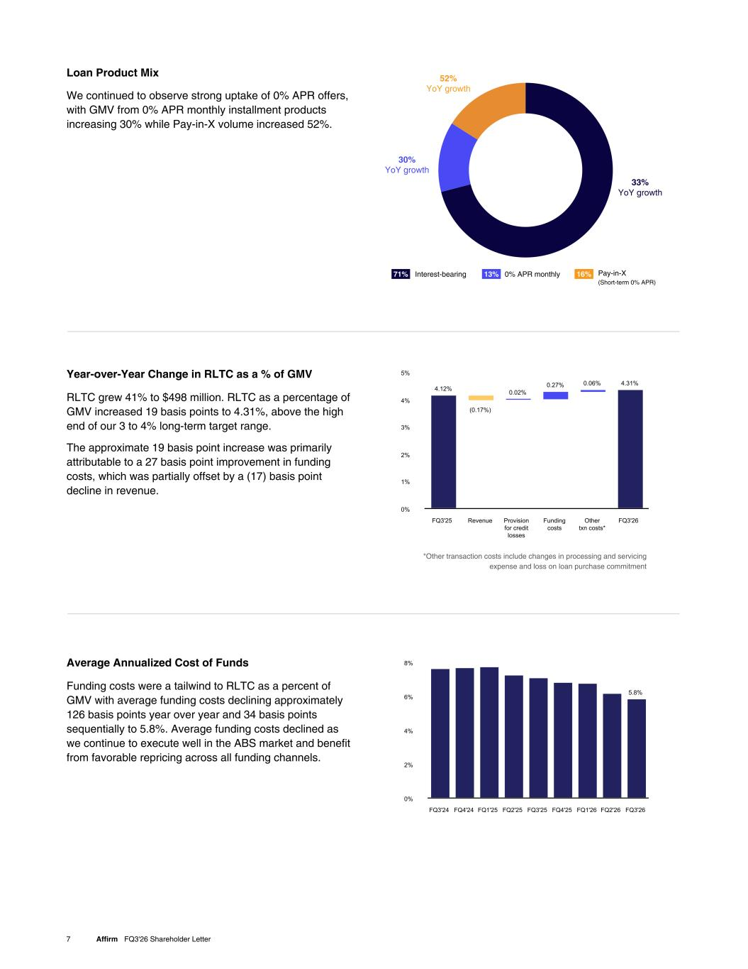
7 Affirm FQ3'26 Shareholder Letter We continued to observe strong uptake of 0% APR offers, with GMV from 0% APR monthly installment products increasing 30% while Pay-in-X volume increased 52%. Loan Product Mix *Other transaction costs include changes in processing and servicing expense and loss on loan purchase commitment Funding costs were a tailwind to RLTC as a percent of GMV with average funding costs declining approximately 126 basis points year over year and 34 basis points sequentially to 5.8%. Average funding costs declined as we continue to execute well in the ABS market and benefit from favorable repricing across all funding channels. Average Annualized Cost of Funds 5.8% FQ3'24 FQ4'24 FQ1'25 FQ2'25 FQ3'25 FQ4'25 FQ1'26 FQ2'26 FQ3'26 0% 2% 4% 6% 8% RLTC grew 41% to $498 million. RLTC as a percentage of GMV increased 19 basis points to 4.31%, above the high end of our 3 to 4% long-term target range. The approximate 19 basis point increase was primarily attributable to a 27 basis point improvement in funding costs, which was partially offset by a (17) basis point decline in revenue. Year-over-Year Change in RLTC as a % of GMV 4.12% (0.17%) 0.02% 0.27% 0.06% 4.31% FQ3'25 Revenue Provision for credit losses Funding costs Other txn costs* FQ3'26 0% 1% 2% 3% 4% 5% 52% YoY growth 33% YoY growth 30% YoY growth 71% 13% 16%Interest-bearing 0% APR monthly Pay-in-X (Short-term 0% APR)

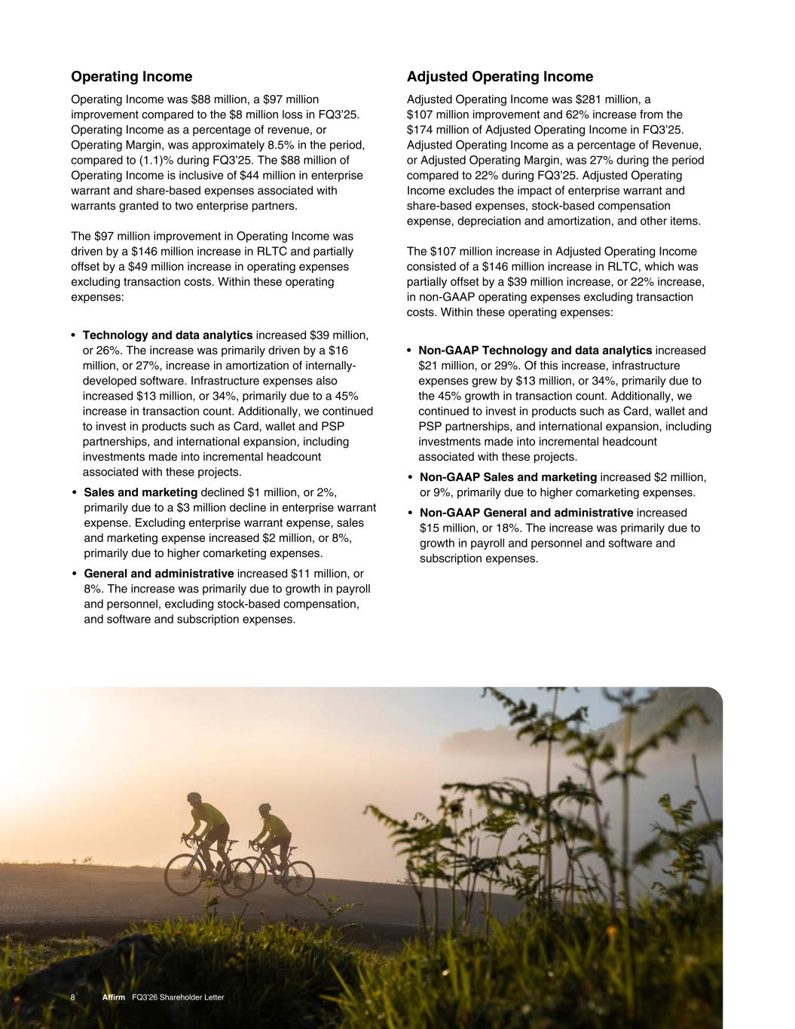
Adjusted Operating Income Adjusted Operating Income was $281 million, a $107 million improvement and 62% increase from the $174 million of Adjusted Operating Income in FQ3’25. Adjusted Operating Income as a percentage of Revenue, or Adjusted Operating Margin, was 27% during the period compared to 22% during FQ3’25. Adjusted Operating Income excludes the impact of enterprise warrant and share-based expenses, stock-based compensation expense, depreciation and amortization, and other items. The $107 million increase in Adjusted Operating Income consisted of a $146 million increase in RLTC, which was partially offset by a $39 million increase, or 22% increase, in non-GAAP operating expenses excluding transaction costs. Within these operating expenses: • Non-GAAP Technology and data analytics increased $21 million, or 29%. Of this increase, infrastructure expenses grew by $13 million, or 34%, primarily due to the 45% growth in transaction count. Additionally, we continued to invest in products such as Card, wallet and PSP partnerships, and international expansion, including investments made into incremental headcount associated with these projects. • Non-GAAP Sales and marketing increased $2 million, or 9%, primarily due to higher comarketing expenses. • Non-GAAP General and administrative increased $15 million, or 18%. The increase was primarily due to growth in payroll and personnel and software and subscription expenses. 8 Affirm FQ3’26 Shareholder Letter Operating Income Operating Income was $88 million, a $97 million improvement compared to the $8 million loss in FQ3’25. Operating Income as a percentage of revenue, or Operating Margin, was approximately 8.5% in the period, compared to (1.1)% during FQ3’25. The $88 million of Operating Income is inclusive of $44 million in enterprise warrant and share-based expenses associated with warrants granted to two enterprise partners. The $97 million improvement in Operating Income was driven by a $146 million increase in RLTC and partially offset by a $49 million increase in operating expenses excluding transaction costs. Within these operating expenses: • Technology and data analytics increased $39 million, or 26%. The increase was primarily driven by a $16 million, or 27%, increase in amortization of internally- developed software. Infrastructure expenses also increased $13 million, or 34%, primarily due to a 45% increase in transaction count. Additionally, we continued to invest in products such as Card, wallet and PSP partnerships, and international expansion, including investments made into incremental headcount associated with these projects. • Sales and marketing declined $1 million, or 2%, primarily due to a $3 million decline in enterprise warrant expense. Excluding enterprise warrant expense, sales and marketing expense increased $2 million, or 8%, primarily due to higher comarketing expenses. • General and administrative increased $11 million, or 8%. The increase was primarily due to growth in payroll and personnel, excluding stock-based compensation, and software and subscription expenses.

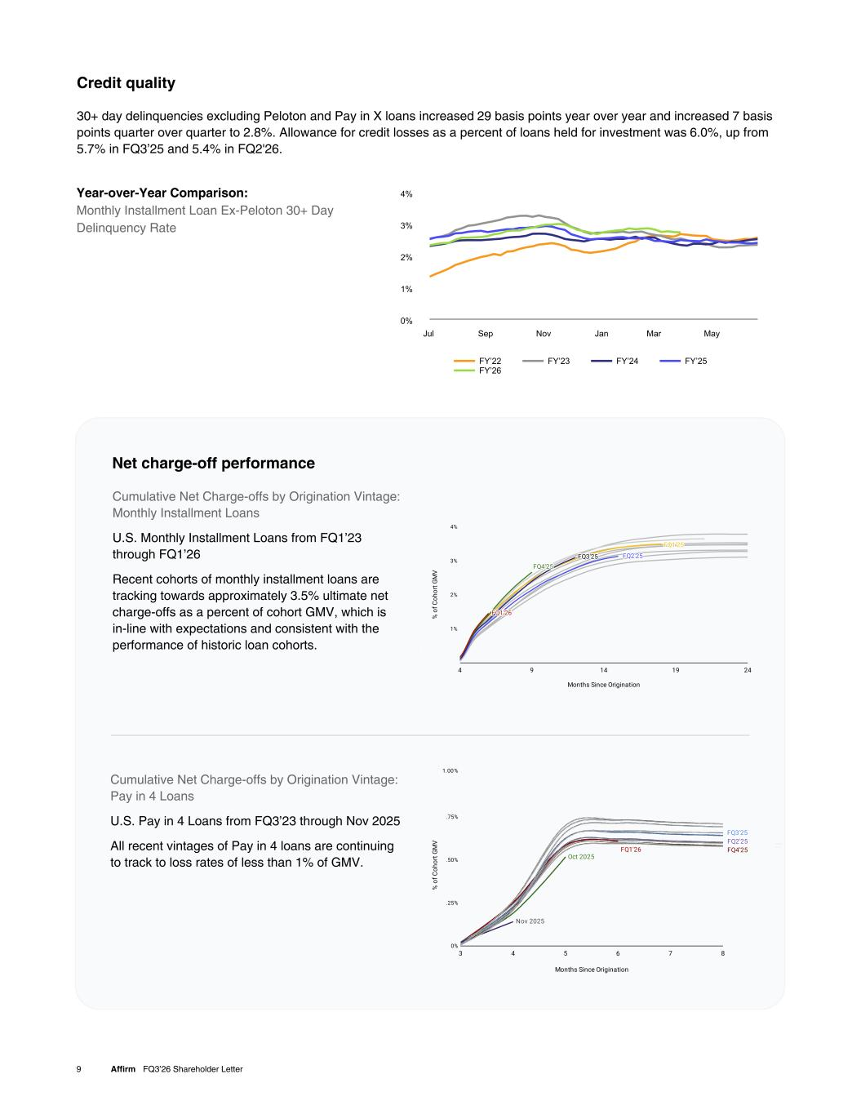
Year-over-Year Comparison: Monthly Installment Loan Ex-Peloton 30+ Day Delinquency Rate 9 Affirm FQ3’26 Shareholder Letter Credit quality 30+ day delinquencies excluding Peloton and Pay in X loans increased 29 basis points year over year and increased 7 basis points quarter over quarter to 2.8%. Allowance for credit losses as a percent of loans held for investment was 6.0%, up from 5.7% in FQ3’25 and 5.4% in FQ2'26. FY’22 FY’23 FY’24 FY’25 FY’26 Jul Sep Nov Jan Mar May 0% 1% 2% 3% 4% Cumulative Net Charge-offs by Origination Vintage: Monthly Installment Loans U.S. Monthly Installment Loans from FQ1’23 through FQ1’26 Recent cohorts of monthly installment loans are tracking towards approximately 3.5% ultimate net charge-offs as a percent of cohort GMV, which is in-line with expectations and consistent with the performance of historic loan cohorts. Net charge-off performance Cumulative Net Charge-offs by Origination Vintage: Pay in 4 Loans U.S. Pay in 4 Loans from FQ3’23 through Nov 2025 All recent vintages of Pay in 4 loans are continuing to track to loss rates of less than 1% of GMV.

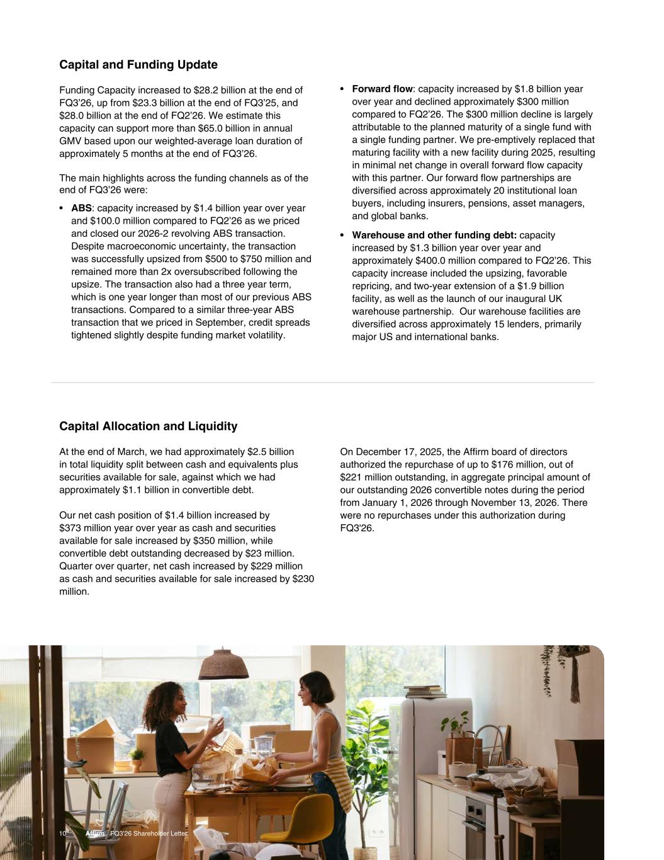
Capital and Funding Update Funding Capacity increased to $28.2 billion at the end of FQ3’26, up from $23.3 billion at the end of FQ3’25, and $28.0 billion at the end of FQ2’26. We estimate this capacity can support more than $65.0 billion in annual GMV based upon our weighted-average loan duration of approximately 5 months at the end of FQ3’26. The main highlights across the funding channels as of the end of FQ3’26 were: • ABS: capacity increased by $1.4 billion year over year and $100.0 million compared to FQ2’26 as we priced and closed our 2026-2 revolving ABS transaction. Despite macroeconomic uncertainty, the transaction was successfully upsized from $500 to $750 million and remained more than 2x oversubscribed following the upsize. The transaction also had a three year term, which is one year longer than most of our previous ABS transactions. Compared to a similar three-year ABS transaction that we priced in September, credit spreads tightened slightly despite funding market volatility. 10 Affirm FQ3’26 Shareholder Letter • Forward flow: capacity increased by $1.8 billion year over year and declined approximately $300 million compared to FQ2’26. The $300 million decline is largely attributable to the planned maturity of a single fund with a single funding partner. We pre-emptively replaced that maturing facility with a new facility during 2025, resulting in minimal net change in overall forward flow capacity with this partner. Our forward flow partnerships are diversified across approximately 20 institutional loan buyers, including insurers, pensions, asset managers, and global banks. • Warehouse and other funding debt: capacity increased by $1.3 billion year over year and approximately $400.0 million compared to FQ2’26. This capacity increase included the upsizing, favorable repricing, and two-year extension of a $1.9 billion facility, as well as the launch of our inaugural UK warehouse partnership. Our warehouse facilities are diversified across approximately 15 lenders, primarily major US and international banks. Capital Allocation and Liquidity At the end of March, we had approximately $2.5 billion in total liquidity split between cash and equivalents plus securities available for sale, against which we had approximately $1.1 billion in convertible debt. Our net cash position of $1.4 billion increased by $373 million year over year as cash and securities available for sale increased by $350 million, while convertible debt outstanding decreased by $23 million. Quarter over quarter, net cash increased by $229 million as cash and securities available for sale increased by $230 million. On December 17, 2025, the Affirm board of directors authorized the repurchase of up to $176 million, out of $221 million outstanding, in aggregate principal amount of our outstanding 2026 convertible notes during the period from January 1, 2026 through November 13, 2026. There were no repurchases under this authorization during FQ3'26.

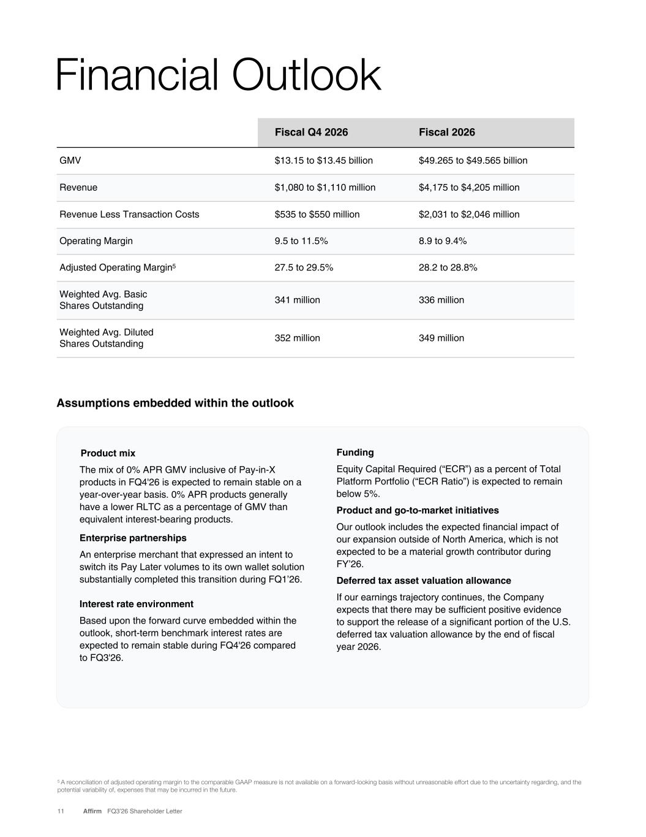
11 Affirm FQ3’26 Shareholder Letter Assumptions embedded within the outlook Product mix The mix of 0% APR GMV inclusive of Pay-in-X products in FQ4'26 is expected to remain stable on a year-over-year basis. 0% APR products generally have a lower RLTC as a percentage of GMV than equivalent interest-bearing products. Enterprise partnerships An enterprise merchant that expressed an intent to switch its Pay Later volumes to its own wallet solution substantially completed this transition during FQ1’26. Interest rate environment Based upon the forward curve embedded within the outlook, short-term benchmark interest rates are expected to remain stable during FQ4'26 compared to FQ3'26. Funding Equity Capital Required (“ECR”) as a percent of Total Platform Portfolio (“ECR Ratio”) is expected to remain below 5%. Product and go-to-market initiatives Our outlook includes the expected financial impact of our expansion outside of North America, which is not expected to be a material growth contributor during FY’26. Deferred tax asset valuation allowance If our earnings trajectory continues, the Company expects that there may be sufficient positive evidence to support the release of a significant portion of the U.S. deferred tax valuation allowance by the end of fiscal year 2026. Fiscal Q4 2026 Fiscal 2026 GMV $13.15 to $13.45 billion $49.265 to $49.565 billion Revenue $1,080 to $1,110 million $4,175 to $4,205 million Revenue Less Transaction Costs $535 to $550 million $2,031 to $2,046 million Operating Margin 9.5 to 11.5% 8.9 to 9.4% Adjusted Operating Margin5 27.5 to 29.5% 28.2 to 28.8% Weighted Avg. Basic Shares Outstanding 341 million 336 million Weighted Avg. Diluted Shares Outstanding 352 million 349 million Financial Outlook 5 A reconciliation of adjusted operating margin to the comparable GAAP measure is not available on a forward-looking basis without unreasonable effort due to the uncertainty regarding, and the potential variability of, expenses that may be incurred in the future.

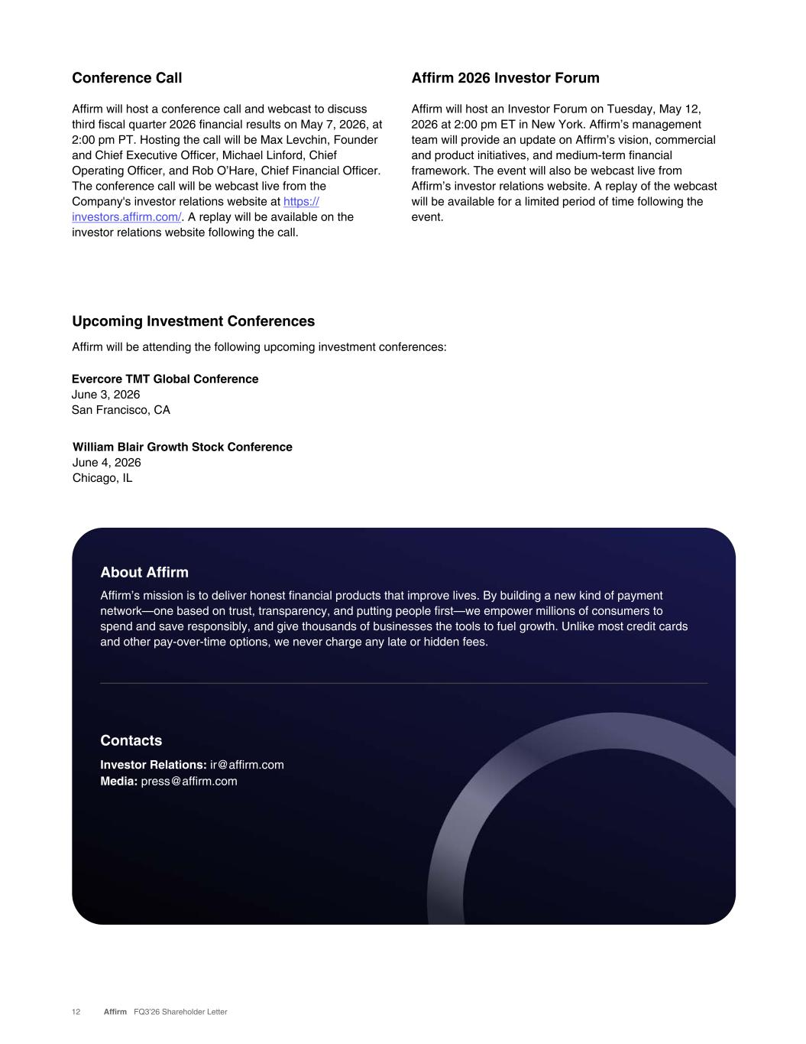
12 Affirm FQ3’26 Shareholder Letter Conference Call Affirm will host a conference call and webcast to discuss third fiscal quarter 2026 financial results on May 7, 2026, at 2:00 pm PT. Hosting the call will be Max Levchin, Founder and Chief Executive Officer, Michael Linford, Chief Operating Officer, and Rob O’Hare, Chief Financial Officer. The conference call will be webcast live from the Company's investor relations website at https:// investors.affirm.com/. A replay will be available on the investor relations website following the call. Upcoming Investment Conferences Affirm will be attending the following upcoming investment conferences: About Affirm Affirm’s mission is to deliver honest financial products that improve lives. By building a new kind of payment network—one based on trust, transparency, and putting people first—we empower millions of consumers to spend and save responsibly, and give thousands of businesses the tools to fuel growth. Unlike most credit cards and other pay-over-time options, we never charge any late or hidden fees. Contacts Investor Relations: ir@affirm.com Media: press@affirm.com Evercore TMT Global Conference June 3, 2026 San Francisco, CA Affirm 2026 Investor Forum Affirm will host an Investor Forum on Tuesday, May 12, 2026 at 2:00 pm ET in New York. Affirm’s management team will provide an update on Affirm’s vision, commercial and product initiatives, and medium-term financial framework. The event will also be webcast live from Affirm’s investor relations website. A replay of the webcast will be available for a limited period of time following the event. William Blair Growth Stock Conference June 4, 2026 Chicago, IL

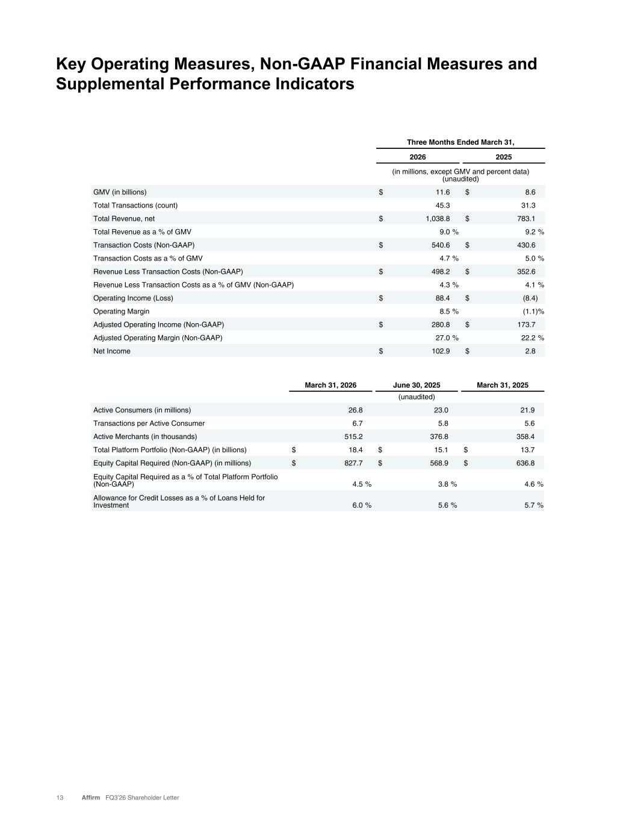
13 Affirm FQ3’26 Shareholder Letter Key Operating Measures, Non-GAAP Financial Measures and Supplemental Performance Indicators Three Months Ended March 31, 2026 2025 (in millions, except GMV and percent data) (unaudited) GMV (in billions) $ 11.6 $ 8.6 Total Transactions (count) 45.3 31.3 Total Revenue, net $ 1,038.8 $ 783.1 Total Revenue as a % of GMV 9.0 % 9.2 % Transaction Costs (Non-GAAP) $ 540.6 $ 430.6 Transaction Costs as a % of GMV 4.7 % 5.0 % Revenue Less Transaction Costs (Non-GAAP) $ 498.2 $ 352.6 Revenue Less Transaction Costs as a % of GMV (Non-GAAP) 4.3 % 4.1 % Operating Income (Loss) $ 88.4 $ (8.4) Operating Margin 8.5 % (1.1) % Adjusted Operating Income (Non-GAAP) $ 280.8 $ 173.7 Adjusted Operating Margin (Non-GAAP) 27.0 % 22.2 % Net Income $ 102.9 $ 2.8 March 31, 2026 June 30, 2025 March 31, 2025 (unaudited) Active Consumers (in millions) 26.8 23.0 21.9 Transactions per Active Consumer 6.7 5.8 5.6 Active Merchants (in thousands) 515.2 376.8 358.4 Total Platform Portfolio (Non-GAAP) (in billions) $ 18.4 $ 15.1 $ 13.7 Equity Capital Required (Non-GAAP) (in millions) $ 827.7 $ 568.9 $ 636.8 Equity Capital Required as a % of Total Platform Portfolio (Non-GAAP) 4.5 % 3.8 % 4.6 % Allowance for Credit Losses as a % of Loans Held for Investment 6.0 % 5.6 % 5.7 %

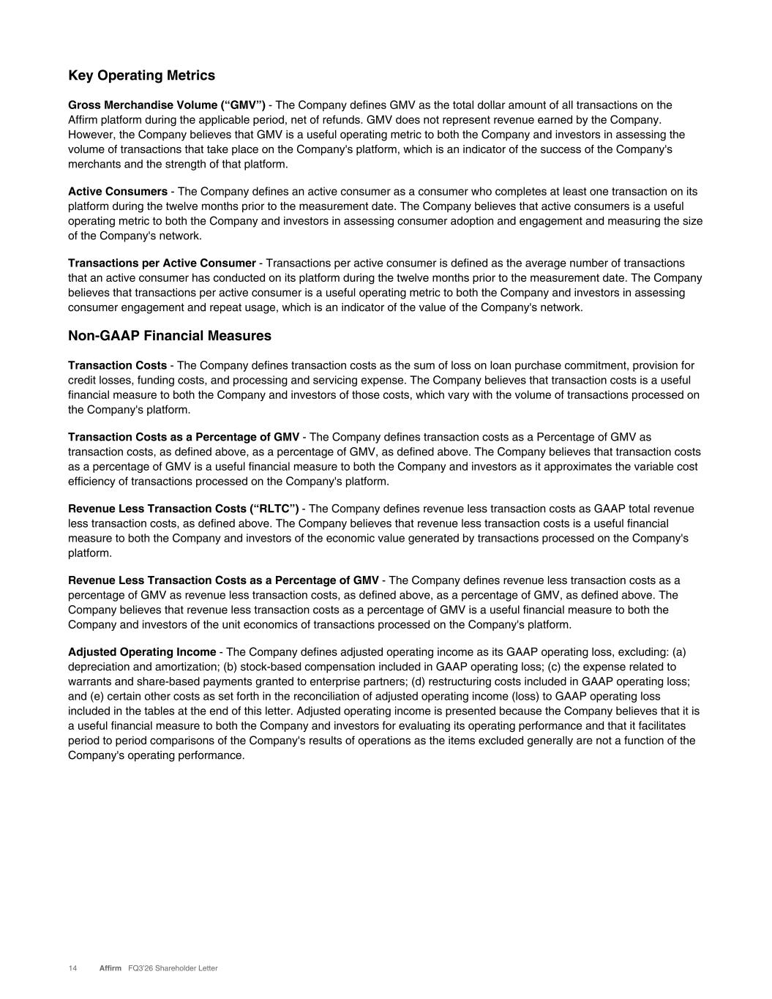
Key Operating Metrics Gross Merchandise Volume (“GMV”) - The Company defines GMV as the total dollar amount of all transactions on the Affirm platform during the applicable period, net of refunds. GMV does not represent revenue earned by the Company. However, the Company believes that GMV is a useful operating metric to both the Company and investors in assessing the volume of transactions that take place on the Company's platform, which is an indicator of the success of the Company's merchants and the strength of that platform. Active Consumers - The Company defines an active consumer as a consumer who completes at least one transaction on its platform during the twelve months prior to the measurement date. The Company believes that active consumers is a useful operating metric to both the Company and investors in assessing consumer adoption and engagement and measuring the size of the Company's network. Transactions per Active Consumer - Transactions per active consumer is defined as the average number of transactions that an active consumer has conducted on its platform during the twelve months prior to the measurement date. The Company believes that transactions per active consumer is a useful operating metric to both the Company and investors in assessing consumer engagement and repeat usage, which is an indicator of the value of the Company's network. Non-GAAP Financial Measures Transaction Costs - The Company defines transaction costs as the sum of loss on loan purchase commitment, provision for credit losses, funding costs, and processing and servicing expense. The Company believes that transaction costs is a useful financial measure to both the Company and investors of those costs, which vary with the volume of transactions processed on the Company's platform. Transaction Costs as a Percentage of GMV - The Company defines transaction costs as a Percentage of GMV as transaction costs, as defined above, as a percentage of GMV, as defined above. The Company believes that transaction costs as a percentage of GMV is a useful financial measure to both the Company and investors as it approximates the variable cost efficiency of transactions processed on the Company's platform. Revenue Less Transaction Costs (“RLTC”) - The Company defines revenue less transaction costs as GAAP total revenue less transaction costs, as defined above. The Company believes that revenue less transaction costs is a useful financial measure to both the Company and investors of the economic value generated by transactions processed on the Company's platform. Revenue Less Transaction Costs as a Percentage of GMV - The Company defines revenue less transaction costs as a percentage of GMV as revenue less transaction costs, as defined above, as a percentage of GMV, as defined above. The Company believes that revenue less transaction costs as a percentage of GMV is a useful financial measure to both the Company and investors of the unit economics of transactions processed on the Company's platform. Adjusted Operating Income - The Company defines adjusted operating income as its GAAP operating loss, excluding: (a) depreciation and amortization; (b) stock-based compensation included in GAAP operating loss; (c) the expense related to warrants and share-based payments granted to enterprise partners; (d) restructuring costs included in GAAP operating loss; and (e) certain other costs as set forth in the reconciliation of adjusted operating income (loss) to GAAP operating loss included in the tables at the end of this letter. Adjusted operating income is presented because the Company believes that it is a useful financial measure to both the Company and investors for evaluating its operating performance and that it facilitates period to period comparisons of the Company's results of operations as the items excluded generally are not a function of the Company's operating performance. 14 Affirm FQ3’26 Shareholder Letter

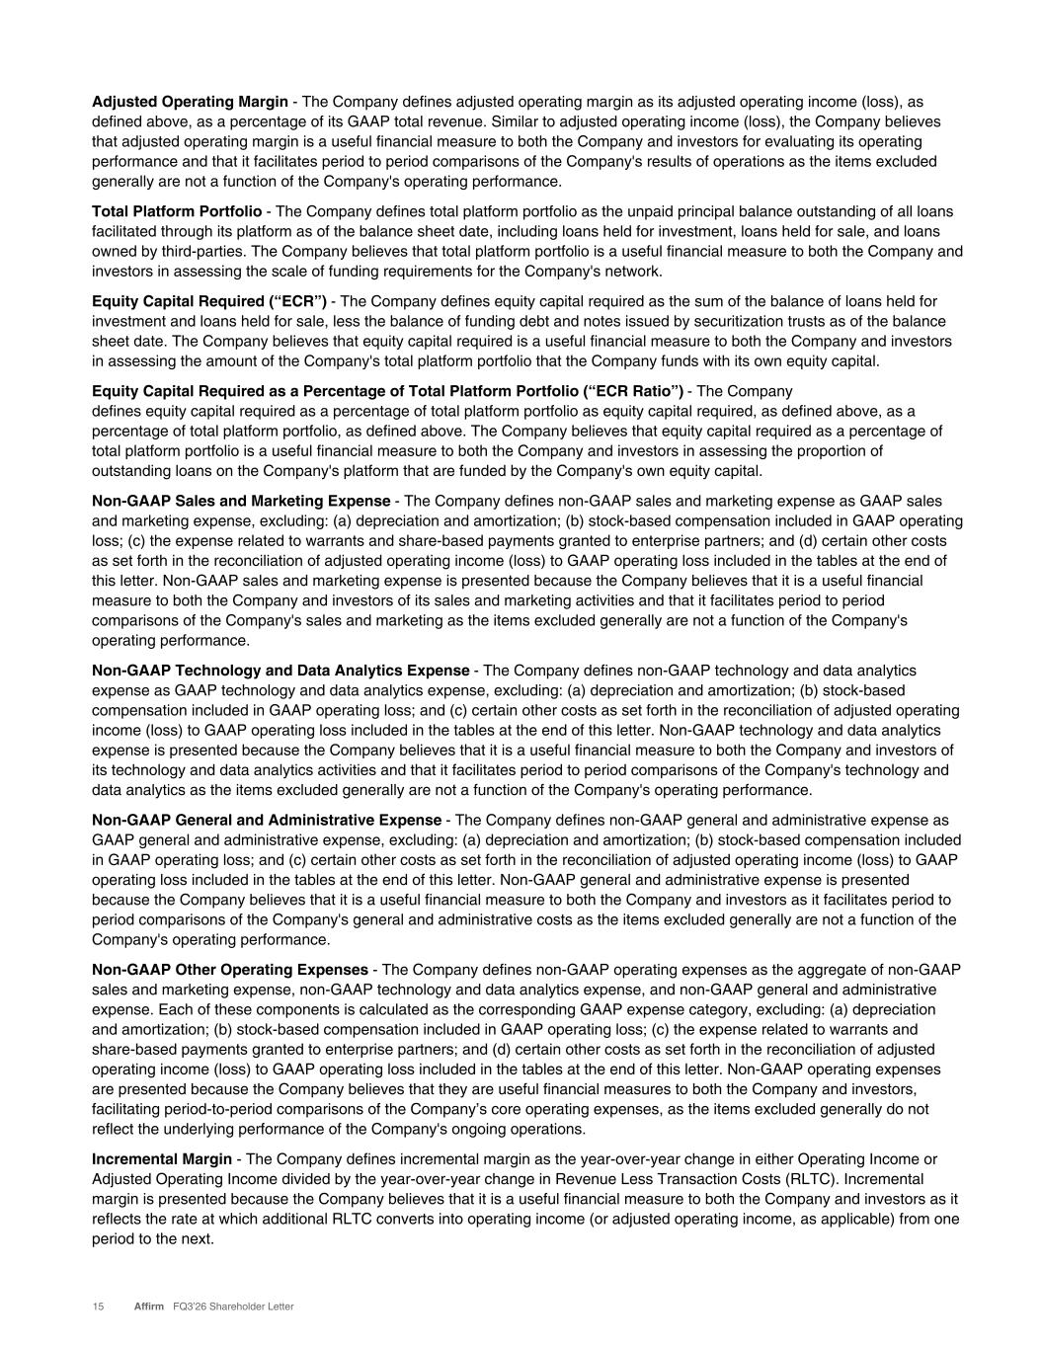
Adjusted Operating Margin - The Company defines adjusted operating margin as its adjusted operating income (loss), as defined above, as a percentage of its GAAP total revenue. Similar to adjusted operating income (loss), the Company believes that adjusted operating margin is a useful financial measure to both the Company and investors for evaluating its operating performance and that it facilitates period to period comparisons of the Company's results of operations as the items excluded generally are not a function of the Company's operating performance. Total Platform Portfolio - The Company defines total platform portfolio as the unpaid principal balance outstanding of all loans facilitated through its platform as of the balance sheet date, including loans held for investment, loans held for sale, and loans owned by third-parties. The Company believes that total platform portfolio is a useful financial measure to both the Company and investors in assessing the scale of funding requirements for the Company's network. Equity Capital Required (“ECR”) - The Company defines equity capital required as the sum of the balance of loans held for investment and loans held for sale, less the balance of funding debt and notes issued by securitization trusts as of the balance sheet date. The Company believes that equity capital required is a useful financial measure to both the Company and investors in assessing the amount of the Company's total platform portfolio that the Company funds with its own equity capital. Equity Capital Required as a Percentage of Total Platform Portfolio (“ECR Ratio”) - The Company defines equity capital required as a percentage of total platform portfolio as equity capital required, as defined above, as a percentage of total platform portfolio, as defined above. The Company believes that equity capital required as a percentage of total platform portfolio is a useful financial measure to both the Company and investors in assessing the proportion of outstanding loans on the Company's platform that are funded by the Company's own equity capital. Non-GAAP Sales and Marketing Expense - The Company defines non-GAAP sales and marketing expense as GAAP sales and marketing expense, excluding: (a) depreciation and amortization; (b) stock-based compensation included in GAAP operating loss; (c) the expense related to warrants and share-based payments granted to enterprise partners; and (d) certain other costs as set forth in the reconciliation of adjusted operating income (loss) to GAAP operating loss included in the tables at the end of this letter. Non-GAAP sales and marketing expense is presented because the Company believes that it is a useful financial measure to both the Company and investors of its sales and marketing activities and that it facilitates period to period comparisons of the Company's sales and marketing as the items excluded generally are not a function of the Company's operating performance. Non-GAAP Technology and Data Analytics Expense - The Company defines non-GAAP technology and data analytics expense as GAAP technology and data analytics expense, excluding: (a) depreciation and amortization; (b) stock-based compensation included in GAAP operating loss; and (c) certain other costs as set forth in the reconciliation of adjusted operating income (loss) to GAAP operating loss included in the tables at the end of this letter. Non-GAAP technology and data analytics expense is presented because the Company believes that it is a useful financial measure to both the Company and investors of its technology and data analytics activities and that it facilitates period to period comparisons of the Company's technology and data analytics as the items excluded generally are not a function of the Company's operating performance. Non-GAAP General and Administrative Expense - The Company defines non-GAAP general and administrative expense as GAAP general and administrative expense, excluding: (a) depreciation and amortization; (b) stock-based compensation included in GAAP operating loss; and (c) certain other costs as set forth in the reconciliation of adjusted operating income (loss) to GAAP operating loss included in the tables at the end of this letter. Non-GAAP general and administrative expense is presented because the Company believes that it is a useful financial measure to both the Company and investors as it facilitates period to period comparisons of the Company's general and administrative costs as the items excluded generally are not a function of the Company's operating performance. Non-GAAP Other Operating Expenses - The Company defines non-GAAP operating expenses as the aggregate of non-GAAP sales and marketing expense, non-GAAP technology and data analytics expense, and non-GAAP general and administrative expense. Each of these components is calculated as the corresponding GAAP expense category, excluding: (a) depreciation and amortization; (b) stock-based compensation included in GAAP operating loss; (c) the expense related to warrants and share-based payments granted to enterprise partners; and (d) certain other costs as set forth in the reconciliation of adjusted operating income (loss) to GAAP operating loss included in the tables at the end of this letter. Non-GAAP operating expenses are presented because the Company believes that they are useful financial measures to both the Company and investors, facilitating period-to-period comparisons of the Company’s core operating expenses, as the items excluded generally do not reflect the underlying performance of the Company's ongoing operations. Incremental Margin - The Company defines incremental margin as the year-over-year change in either Operating Income or Adjusted Operating Income divided by the year-over-year change in Revenue Less Transaction Costs (RLTC). Incremental margin is presented because the Company believes that it is a useful financial measure to both the Company and investors as it reflects the rate at which additional RLTC converts into operating income (or adjusted operating income, as applicable) from one period to the next. 15 Affirm FQ3’26 Shareholder Letter

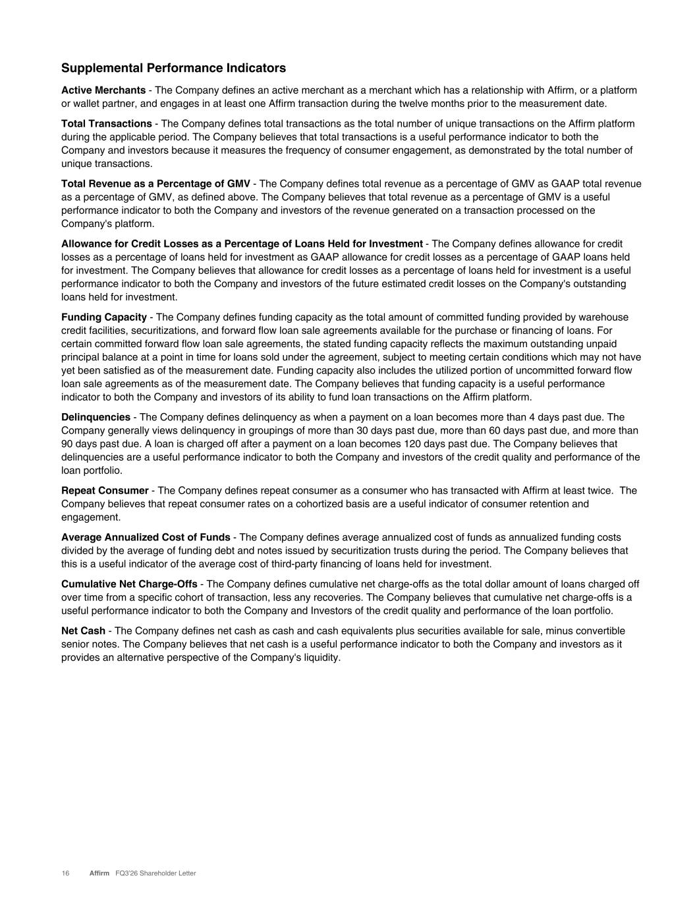
Supplemental Performance Indicators Active Merchants - The Company defines an active merchant as a merchant which has a relationship with Affirm, or a platform or wallet partner, and engages in at least one Affirm transaction during the twelve months prior to the measurement date. Total Transactions - The Company defines total transactions as the total number of unique transactions on the Affirm platform during the applicable period. The Company believes that total transactions is a useful performance indicator to both the Company and investors because it measures the frequency of consumer engagement, as demonstrated by the total number of unique transactions. Total Revenue as a Percentage of GMV - The Company defines total revenue as a percentage of GMV as GAAP total revenue as a percentage of GMV, as defined above. The Company believes that total revenue as a percentage of GMV is a useful performance indicator to both the Company and investors of the revenue generated on a transaction processed on the Company's platform. Allowance for Credit Losses as a Percentage of Loans Held for Investment - The Company defines allowance for credit losses as a percentage of loans held for investment as GAAP allowance for credit losses as a percentage of GAAP loans held for investment. The Company believes that allowance for credit losses as a percentage of loans held for investment is a useful performance indicator to both the Company and investors of the future estimated credit losses on the Company's outstanding loans held for investment. Funding Capacity - The Company defines funding capacity as the total amount of committed funding provided by warehouse credit facilities, securitizations, and forward flow loan sale agreements available for the purchase or financing of loans. For certain committed forward flow loan sale agreements, the stated funding capacity reflects the maximum outstanding unpaid principal balance at a point in time for loans sold under the agreement, subject to meeting certain conditions which may not have yet been satisfied as of the measurement date. Funding capacity also includes the utilized portion of uncommitted forward flow loan sale agreements as of the measurement date. The Company believes that funding capacity is a useful performance indicator to both the Company and investors of its ability to fund loan transactions on the Affirm platform. Delinquencies - The Company defines delinquency as when a payment on a loan becomes more than 4 days past due. The Company generally views delinquency in groupings of more than 30 days past due, more than 60 days past due, and more than 90 days past due. A loan is charged off after a payment on a loan becomes 120 days past due. The Company believes that delinquencies are a useful performance indicator to both the Company and investors of the credit quality and performance of the loan portfolio. Repeat Consumer - The Company defines repeat consumer as a consumer who has transacted with Affirm at least twice. The Company believes that repeat consumer rates on a cohortized basis are a useful indicator of consumer retention and engagement. Average Annualized Cost of Funds - The Company defines average annualized cost of funds as annualized funding costs divided by the average of funding debt and notes issued by securitization trusts during the period. The Company believes that this is a useful indicator of the average cost of third-party financing of loans held for investment. Cumulative Net Charge-Offs - The Company defines cumulative net charge-offs as the total dollar amount of loans charged off over time from a specific cohort of transaction, less any recoveries. The Company believes that cumulative net charge-offs is a useful performance indicator to both the Company and Investors of the credit quality and performance of the loan portfolio. Net Cash - The Company defines net cash as cash and cash equivalents plus securities available for sale, minus convertible senior notes. The Company believes that net cash is a useful performance indicator to both the Company and investors as it provides an alternative perspective of the Company's liquidity. 16 Affirm FQ3’26 Shareholder Letter

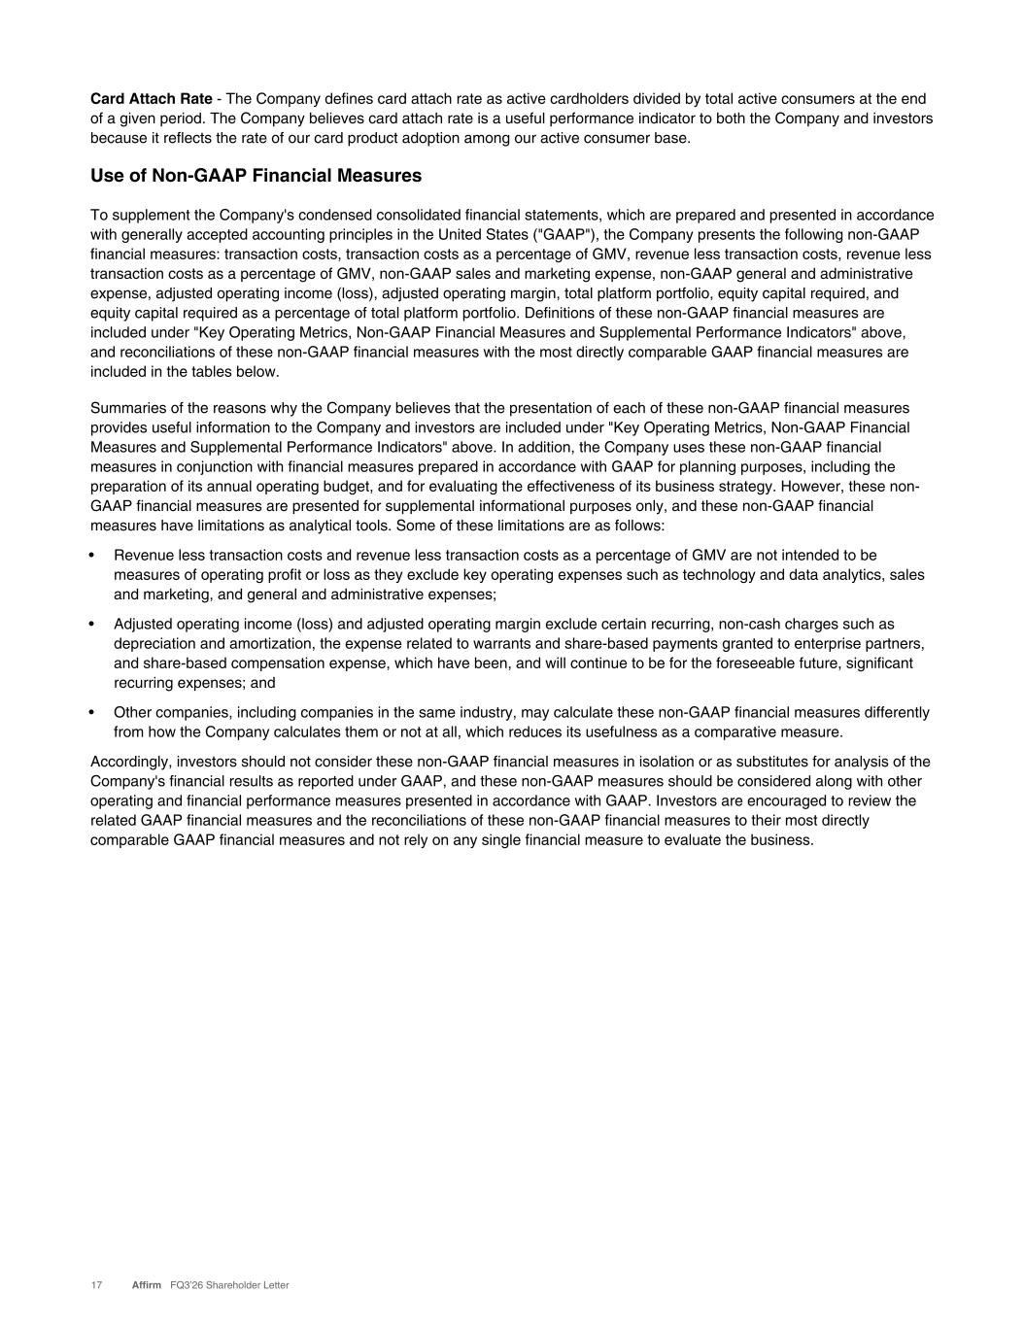
Card Attach Rate - The Company defines card attach rate as active cardholders divided by total active consumers at the end of a given period. The Company believes card attach rate is a useful performance indicator to both the Company and investors because it reflects the rate of our card product adoption among our active consumer base. Use of Non-GAAP Financial Measures To supplement the Company's condensed consolidated financial statements, which are prepared and presented in accordance with generally accepted accounting principles in the United States ("GAAP"), the Company presents the following non-GAAP financial measures: transaction costs, transaction costs as a percentage of GMV, revenue less transaction costs, revenue less transaction costs as a percentage of GMV, non-GAAP sales and marketing expense, non-GAAP general and administrative expense, adjusted operating income (loss), adjusted operating margin, total platform portfolio, equity capital required, and equity capital required as a percentage of total platform portfolio. Definitions of these non-GAAP financial measures are included under "Key Operating Metrics, Non-GAAP Financial Measures and Supplemental Performance Indicators" above, and reconciliations of these non-GAAP financial measures with the most directly comparable GAAP financial measures are included in the tables below. Summaries of the reasons why the Company believes that the presentation of each of these non-GAAP financial measures provides useful information to the Company and investors are included under "Key Operating Metrics, Non-GAAP Financial Measures and Supplemental Performance Indicators" above. In addition, the Company uses these non-GAAP financial measures in conjunction with financial measures prepared in accordance with GAAP for planning purposes, including the preparation of its annual operating budget, and for evaluating the effectiveness of its business strategy. However, these non- GAAP financial measures are presented for supplemental informational purposes only, and these non-GAAP financial measures have limitations as analytical tools. Some of these limitations are as follows: • Revenue less transaction costs and revenue less transaction costs as a percentage of GMV are not intended to be measures of operating profit or loss as they exclude key operating expenses such as technology and data analytics, sales and marketing, and general and administrative expenses; • Adjusted operating income (loss) and adjusted operating margin exclude certain recurring, non-cash charges such as depreciation and amortization, the expense related to warrants and share-based payments granted to enterprise partners, and share-based compensation expense, which have been, and will continue to be for the foreseeable future, significant recurring expenses; and • Other companies, including companies in the same industry, may calculate these non-GAAP financial measures differently from how the Company calculates them or not at all, which reduces its usefulness as a comparative measure. Accordingly, investors should not consider these non-GAAP financial measures in isolation or as substitutes for analysis of the Company's financial results as reported under GAAP, and these non-GAAP measures should be considered along with other operating and financial performance measures presented in accordance with GAAP. Investors are encouraged to review the related GAAP financial measures and the reconciliations of these non-GAAP financial measures to their most directly comparable GAAP financial measures and not rely on any single financial measure to evaluate the business. 17 Affirm FQ3’26 Shareholder Letter

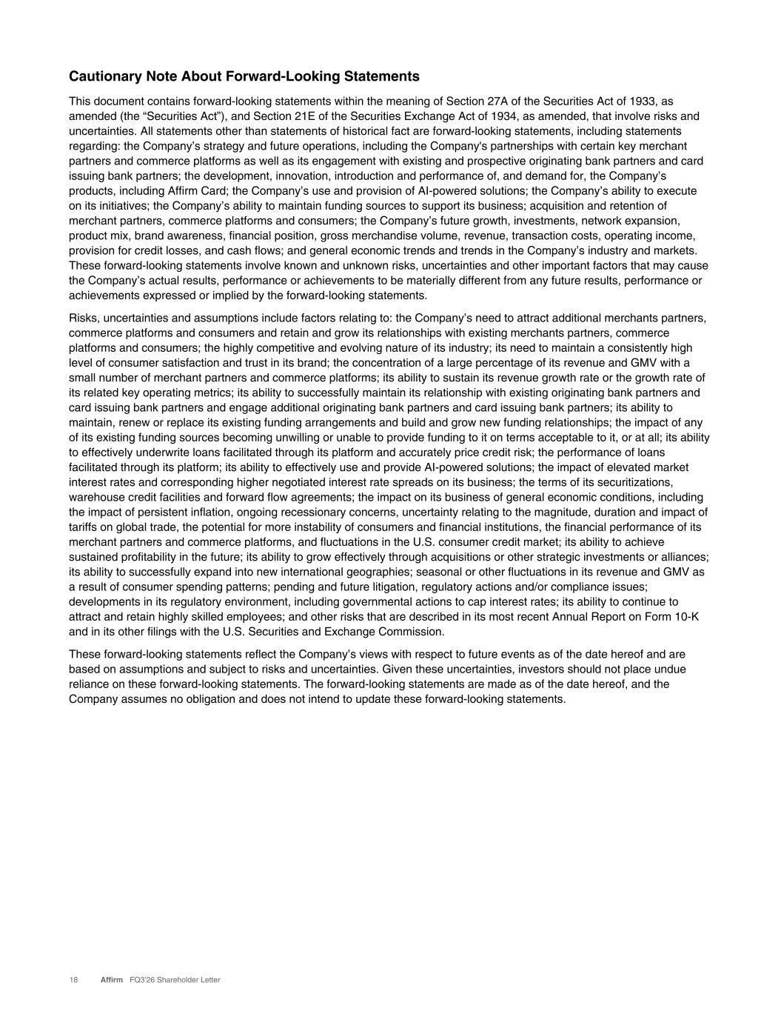
Cautionary Note About Forward-Looking Statements This document contains forward-looking statements within the meaning of Section 27A of the Securities Act of 1933, as amended (the “Securities Act”), and Section 21E of the Securities Exchange Act of 1934, as amended, that involve risks and uncertainties. All statements other than statements of historical fact are forward-looking statements, including statements regarding: the Company’s strategy and future operations, including the Company's partnerships with certain key merchant partners and commerce platforms as well as its engagement with existing and prospective originating bank partners and card issuing bank partners; the development, innovation, introduction and performance of, and demand for, the Company’s products, including Affirm Card; the Company’s use and provision of AI-powered solutions; the Company’s ability to execute on its initiatives; the Company’s ability to maintain funding sources to support its business; acquisition and retention of merchant partners, commerce platforms and consumers; the Company’s future growth, investments, network expansion, product mix, brand awareness, financial position, gross merchandise volume, revenue, transaction costs, operating income, provision for credit losses, and cash flows; and general economic trends and trends in the Company’s industry and markets. These forward-looking statements involve known and unknown risks, uncertainties and other important factors that may cause the Company’s actual results, performance or achievements to be materially different from any future results, performance or achievements expressed or implied by the forward-looking statements. Risks, uncertainties and assumptions include factors relating to: the Company’s need to attract additional merchants partners, commerce platforms and consumers and retain and grow its relationships with existing merchants partners, commerce platforms and consumers; the highly competitive and evolving nature of its industry; its need to maintain a consistently high level of consumer satisfaction and trust in its brand; the concentration of a large percentage of its revenue and GMV with a small number of merchant partners and commerce platforms; its ability to sustain its revenue growth rate or the growth rate of its related key operating metrics; its ability to successfully maintain its relationship with existing originating bank partners and card issuing bank partners and engage additional originating bank partners and card issuing bank partners; its ability to maintain, renew or replace its existing funding arrangements and build and grow new funding relationships; the impact of any of its existing funding sources becoming unwilling or unable to provide funding to it on terms acceptable to it, or at all; its ability to effectively underwrite loans facilitated through its platform and accurately price credit risk; the performance of loans facilitated through its platform; its ability to effectively use and provide AI-powered solutions; the impact of elevated market interest rates and corresponding higher negotiated interest rate spreads on its business; the terms of its securitizations, warehouse credit facilities and forward flow agreements; the impact on its business of general economic conditions, including the impact of persistent inflation, ongoing recessionary concerns, uncertainty relating to the magnitude, duration and impact of tariffs on global trade, the potential for more instability of consumers and financial institutions, the financial performance of its merchant partners and commerce platforms, and fluctuations in the U.S. consumer credit market; its ability to achieve sustained profitability in the future; its ability to grow effectively through acquisitions or other strategic investments or alliances; its ability to successfully expand into new international geographies; seasonal or other fluctuations in its revenue and GMV as a result of consumer spending patterns; pending and future litigation, regulatory actions and/or compliance issues; developments in its regulatory environment, including governmental actions to cap interest rates; its ability to continue to attract and retain highly skilled employees; and other risks that are described in its most recent Annual Report on Form 10-K and in its other filings with the U.S. Securities and Exchange Commission. These forward-looking statements reflect the Company’s views with respect to future events as of the date hereof and are based on assumptions and subject to risks and uncertainties. Given these uncertainties, investors should not place undue reliance on these forward-looking statements. The forward-looking statements are made as of the date hereof, and the Company assumes no obligation and does not intend to update these forward-looking statements. 18 Affirm FQ3’26 Shareholder Letter

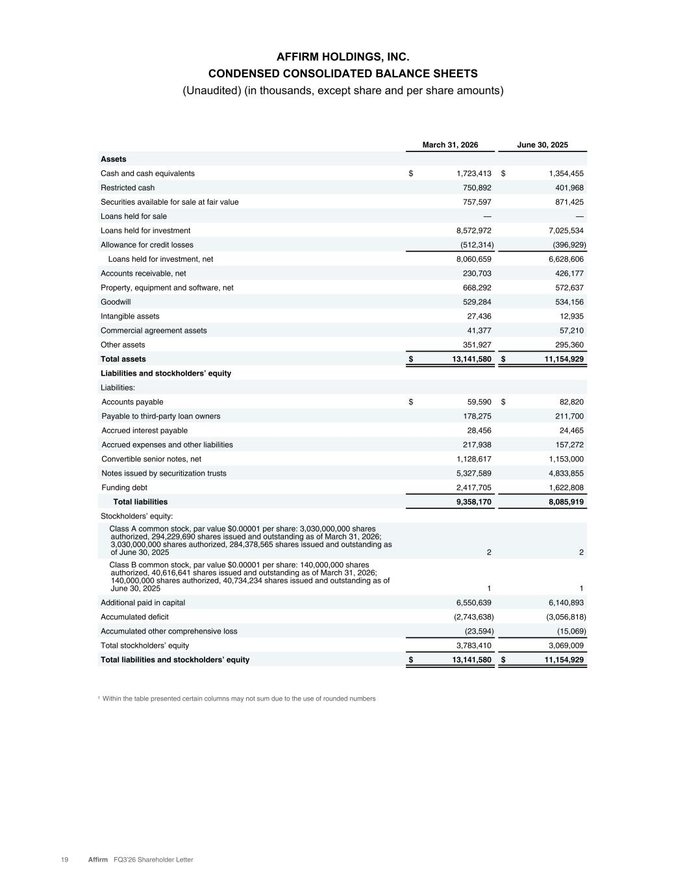
AFFIRM HOLDINGS, INC. CONDENSED CONSOLIDATED BALANCE SHEETS (Unaudited) (in thousands, except share and per share amounts) 19 Affirm FQ3’26 Shareholder Letter March 31, 2026 June 30, 2025 Assets Cash and cash equivalents $ 1,723,413 $ 1,354,455 Restricted cash 750,892 401,968 Securities available for sale at fair value 757,597 871,425 Loans held for sale — — Loans held for investment 8,572,972 7,025,534 Allowance for credit losses (512,314) (396,929) Loans held for investment, net 8,060,659 6,628,606 Accounts receivable, net 230,703 426,177 Property, equipment and software, net 668,292 572,637 Goodwill 529,284 534,156 Intangible assets 27,436 12,935 Commercial agreement assets 41,377 57,210 Other assets 351,927 295,360 Total assets $ 13,141,580 $ 11,154,929 Liabilities and stockholders’ equity Liabilities: Accounts payable $ 59,590 $ 82,820 Payable to third-party loan owners 178,275 211,700 Accrued interest payable 28,456 24,465 Accrued expenses and other liabilities 217,938 157,272 Convertible senior notes, net 1,128,617 1,153,000 Notes issued by securitization trusts 5,327,589 4,833,855 Funding debt 2,417,705 1,622,808 Total liabilities 9,358,170 8,085,919 Stockholders’ equity: Class A common stock, par value $0.00001 per share: 3,030,000,000 shares authorized, 294,229,690 shares issued and outstanding as of March 31, 2026; 3,030,000,000 shares authorized, 284,378,565 shares issued and outstanding as of June 30, 2025 2 2 Class B common stock, par value $0.00001 per share: 140,000,000 shares authorized, 40,616,641 shares issued and outstanding as of March 31, 2026; 140,000,000 shares authorized, 40,734,234 shares issued and outstanding as of June 30, 2025 1 1 Additional paid in capital 6,550,639 6,140,893 Accumulated deficit (2,743,638) (3,056,818) Accumulated other comprehensive loss (23,594) (15,069) Total stockholders’ equity 3,783,410 3,069,009 Total liabilities and stockholders’ equity $ 13,141,580 $ 11,154,929 1 Within the table presented certain columns may not sum due to the use of rounded numbers

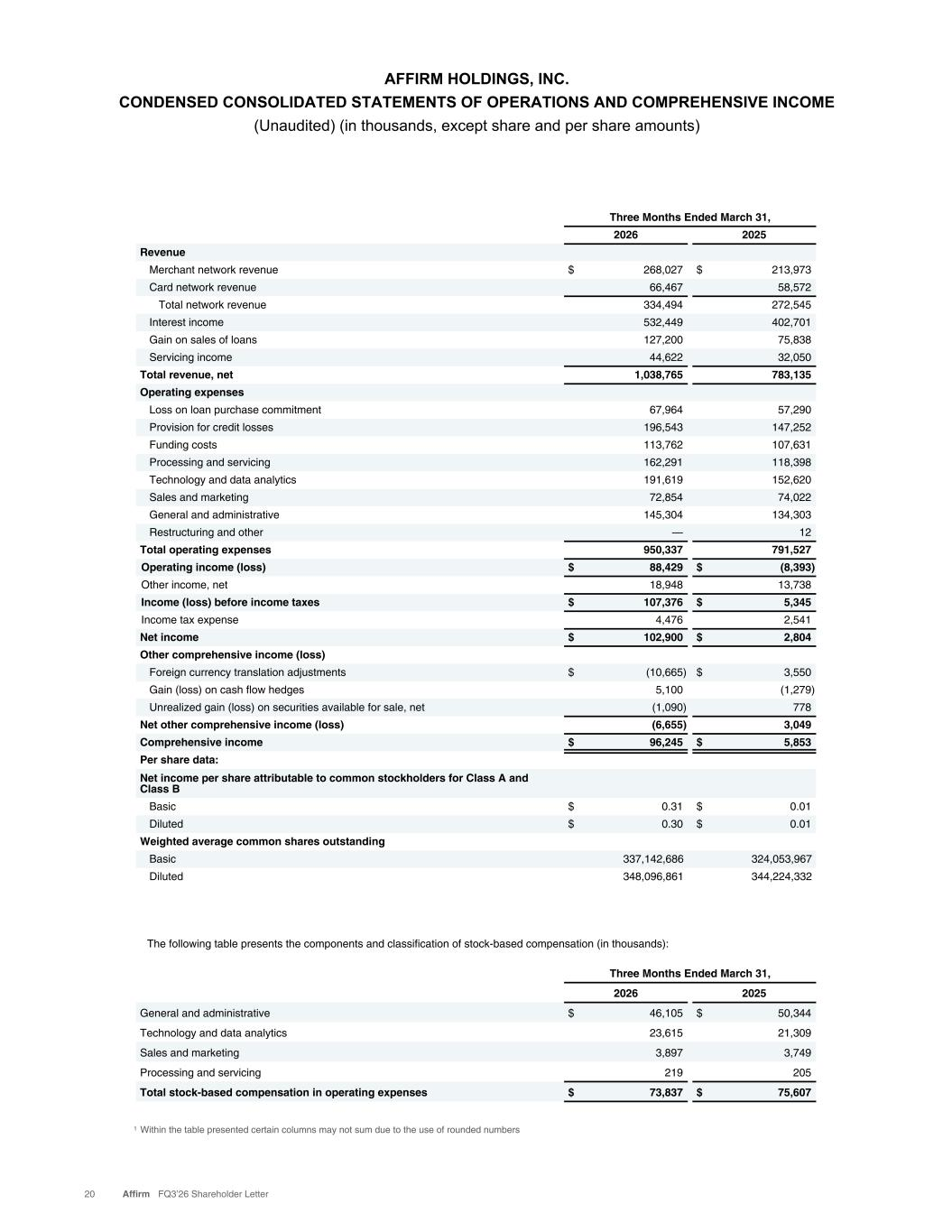
AFFIRM HOLDINGS, INC. CONDENSED CONSOLIDATED STATEMENTS OF OPERATIONS AND COMPREHENSIVE INCOME (Unaudited) (in thousands, except share and per share amounts) 20 Affirm FQ3’26 Shareholder Letter Three Months Ended March 31, 2026 2025 Revenue Merchant network revenue $ 268,027 $ 213,973 Card network revenue 66,467 58,572 Total network revenue 334,494 272,545 Interest income 532,449 402,701 Gain on sales of loans 127,200 75,838 Servicing income 44,622 32,050 Total revenue, net 1,038,765 783,135 Operating expenses Loss on loan purchase commitment 67,964 57,290 Provision for credit losses 196,543 147,252 Funding costs 113,762 107,631 Processing and servicing 162,291 118,398 Technology and data analytics 191,619 152,620 Sales and marketing 72,854 74,022 General and administrative 145,304 134,303 Restructuring and other — 12 Total operating expenses 950,337 791,527 Operating income (loss) $ 88,429 $ (8,393) Other income, net 18,948 13,738 Income (loss) before income taxes $ 107,376 $ 5,345 Income tax expense 4,476 2,541 Net income $ 102,900 $ 2,804 Other comprehensive income (loss) Foreign currency translation adjustments $ (10,665) $ 3,550 Gain (loss) on cash flow hedges 5,100 (1,279) Unrealized gain (loss) on securities available for sale, net (1,090) 778 Net other comprehensive income (loss) (6,655) 3,049 Comprehensive income $ 96,245 $ 5,853 Per share data: Net income per share attributable to common stockholders for Class A and Class B Basic $ 0.31 $ 0.01 Diluted $ 0.30 $ 0.01 Weighted average common shares outstanding Basic 337,142,686 324,053,967 Diluted 348,096,861 344,224,332 Three Months Ended March 31, 2026 2025 General and administrative $ 46,105 $ 50,344 Technology and data analytics 23,615 21,309 Sales and marketing 3,897 3,749 Processing and servicing 219 205 Total stock-based compensation in operating expenses $ 73,837 $ 75,607 The following table presents the components and classification of stock-based compensation (in thousands): 1 Within the table presented certain columns may not sum due to the use of rounded numbers

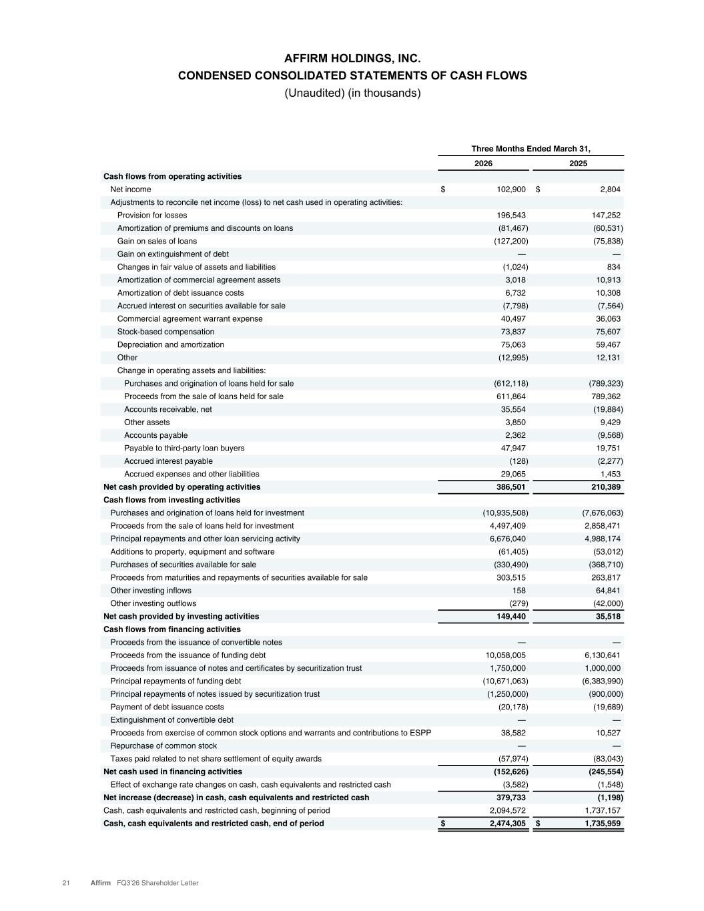
AFFIRM HOLDINGS, INC. CONDENSED CONSOLIDATED STATEMENTS OF CASH FLOWS (Unaudited) (in thousands) 21 Affirm FQ3’26 Shareholder Letter Three Months Ended March 31, 2026 2025 Cash flows from operating activities Net income $ 102,900 $ 2,804 Adjustments to reconcile net income (loss) to net cash used in operating activities: Provision for losses 196,543 147,252 Amortization of premiums and discounts on loans (81,467) (60,531) Gain on sales of loans (127,200) (75,838) Gain on extinguishment of debt — — Changes in fair value of assets and liabilities (1,024) 834 Amortization of commercial agreement assets 3,018 10,913 Amortization of debt issuance costs 6,732 10,308 Accrued interest on securities available for sale (7,798) (7,564) Commercial agreement warrant expense 40,497 36,063 Stock-based compensation 73,837 75,607 Depreciation and amortization 75,063 59,467 Other (12,995) 12,131 Change in operating assets and liabilities: Purchases and origination of loans held for sale (612,118) (789,323) Proceeds from the sale of loans held for sale 611,864 789,362 Accounts receivable, net 35,554 (19,884) Other assets 3,850 9,429 Accounts payable 2,362 (9,568) Payable to third-party loan buyers 47,947 19,751 Accrued interest payable (128) (2,277) Accrued expenses and other liabilities 29,065 1,453 Net cash provided by operating activities 386,501 210,389 Cash flows from investing activities Purchases and origination of loans held for investment (10,935,508) (7,676,063) Proceeds from the sale of loans held for investment 4,497,409 2,858,471 Principal repayments and other loan servicing activity 6,676,040 4,988,174 Additions to property, equipment and software (61,405) (53,012) Purchases of securities available for sale (330,490) (368,710) Proceeds from maturities and repayments of securities available for sale 303,515 263,817 Other investing inflows 158 64,841 Other investing outflows (279) (42,000) Net cash provided by investing activities 149,440 35,518 Cash flows from financing activities Proceeds from the issuance of convertible notes — — Proceeds from the issuance of funding debt 10,058,005 6,130,641 Proceeds from issuance of notes and certificates by securitization trust 1,750,000 1,000,000 Principal repayments of funding debt (10,671,063) (6,383,990) Principal repayments of notes issued by securitization trust (1,250,000) (900,000) Payment of debt issuance costs (20,178) (19,689) Extinguishment of convertible debt — — Proceeds from exercise of common stock options and warrants and contributions to ESPP 38,582 10,527 Repurchase of common stock — — Taxes paid related to net share settlement of equity awards (57,974) (83,043) Net cash used in financing activities (152,626) (245,554) Effect of exchange rate changes on cash, cash equivalents and restricted cash (3,582) (1,548) Net increase (decrease) in cash, cash equivalents and restricted cash 379,733 (1,198) Cash, cash equivalents and restricted cash, beginning of period 2,094,572 1,737,157 Cash, cash equivalents and restricted cash, end of period $ 2,474,305 $ 1,735,959

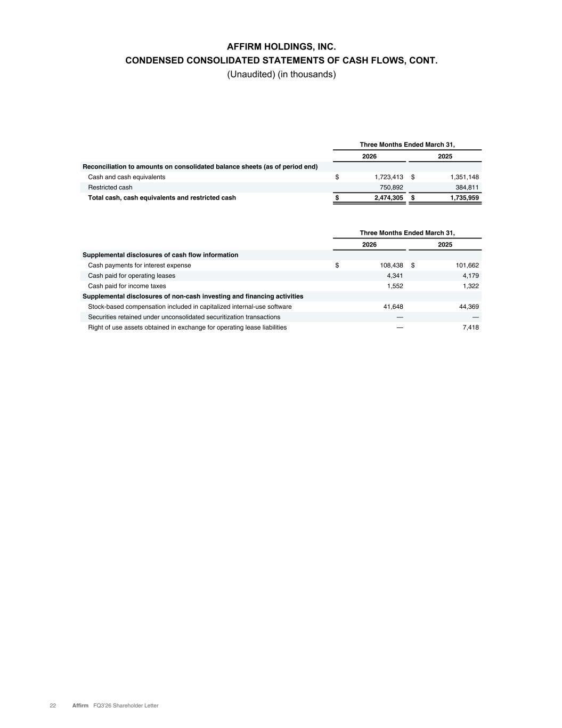
AFFIRM HOLDINGS, INC. CONDENSED CONSOLIDATED STATEMENTS OF CASH FLOWS, CONT. (Unaudited) (in thousands) 22 Affirm FQ3’26 Shareholder Letter Three Months Ended March 31, 2026 2025 Supplemental disclosures of cash flow information Cash payments for interest expense $ 108,438 $ 101,662 Cash paid for operating leases 4,341 4,179 Cash paid for income taxes 1,552 1,322 Supplemental disclosures of non-cash investing and financing activities Stock-based compensation included in capitalized internal-use software 41,648 44,369 Securities retained under unconsolidated securitization transactions — — Right of use assets obtained in exchange for operating lease liabilities — 7,418 Three Months Ended March 31, 2026 2025 Reconciliation to amounts on consolidated balance sheets (as of period end) Cash and cash equivalents $ 1,723,413 $ 1,351,148 Restricted cash 750,892 384,811 Total cash, cash equivalents and restricted cash $ 2,474,305 $ 1,735,959

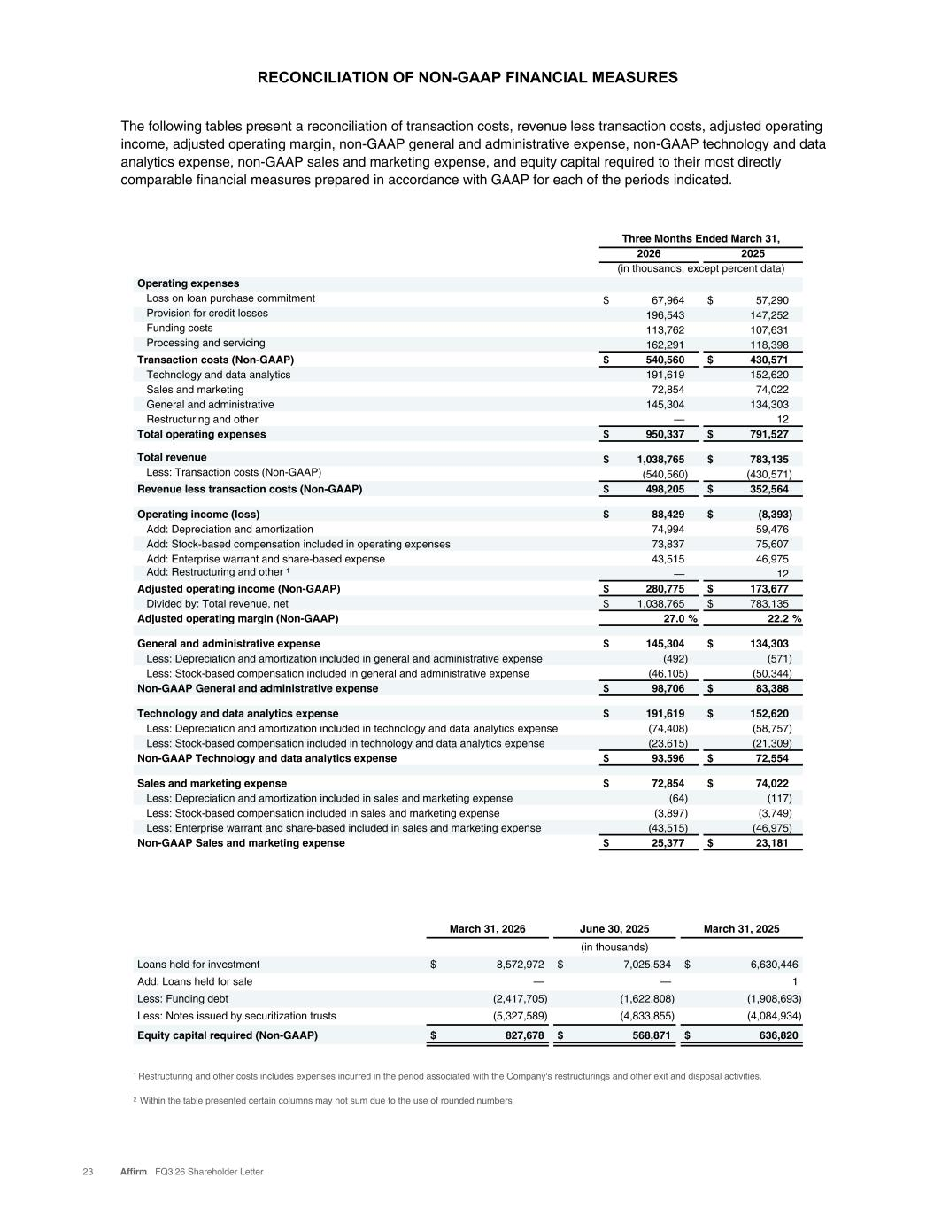
RECONCILIATION OF NON-GAAP FINANCIAL MEASURES 23 Affirm FQ3’26 Shareholder Letter The following tables present a reconciliation of transaction costs, revenue less transaction costs, adjusted operating income, adjusted operating margin, non-GAAP general and administrative expense, non-GAAP technology and data analytics expense, non-GAAP sales and marketing expense, and equity capital required to their most directly comparable financial measures prepared in accordance with GAAP for each of the periods indicated. Three Months Ended March 31, 2026 2025 (in thousands, except percent data) Operating expenses Loss on loan purchase commitment $ 67,964 $ 57,290 Provision for credit losses 196,543 147,252 Funding costs 113,762 107,631 Processing and servicing 162,291 118,398 Transaction costs (Non-GAAP) $ 540,560 $ 430,571 Technology and data analytics 191,619 152,620 Sales and marketing 72,854 74,022 General and administrative 145,304 134,303 Restructuring and other — 12 Total operating expenses $ 950,337 $ 791,527 Total revenue $ 1,038,765 $ 783,135 Less: Transaction costs (Non-GAAP) (540,560) (430,571) Revenue less transaction costs (Non-GAAP) $ 498,205 $ 352,564 Operating income (loss) $ 88,429 $ (8,393) Add: Depreciation and amortization 74,994 59,476 Add: Stock-based compensation included in operating expenses 73,837 75,607 Add: Enterprise warrant and share-based expense 43,515 46,975 Add: Restructuring and other 1 — 12 Adjusted operating income (Non-GAAP) $ 280,775 $ 173,677 Divided by: Total revenue, net $ 1,038,765 $ 783,135 Adjusted operating margin (Non-GAAP) 27.0 % 22.2 % General and administrative expense $ 145,304 $ 134,303 Less: Depreciation and amortization included in general and administrative expense (492) (571) Less: Stock-based compensation included in general and administrative expense (46,105) (50,344) Non-GAAP General and administrative expense $ 98,706 $ 83,388 Technology and data analytics expense $ 191,619 $ 152,620 Less: Depreciation and amortization included in technology and data analytics expense (74,408) (58,757) Less: Stock-based compensation included in technology and data analytics expense (23,615) (21,309) Non-GAAP Technology and data analytics expense $ 93,596 $ 72,554 Sales and marketing expense $ 72,854 $ 74,022 Less: Depreciation and amortization included in sales and marketing expense (64) (117) Less: Stock-based compensation included in sales and marketing expense (3,897) (3,749) Less: Enterprise warrant and share-based included in sales and marketing expense (43,515) (46,975) Non-GAAP Sales and marketing expense $ 25,377 $ 23,181 March 31, 2026 June 30, 2025 March 31, 2025 (in thousands) Loans held for investment $ 8,572,972 $ 7,025,534 $ 6,630,446 Add: Loans held for sale — — 1 Less: Funding debt (2,417,705) (1,622,808) (1,908,693) Less: Notes issued by securitization trusts (5,327,589) (4,833,855) (4,084,934) Equity capital required (Non-GAAP) $ 827,678 $ 568,871 $ 636,820 1 Restructuring and other costs includes expenses incurred in the period associated with the Company's restructurings and other exit and disposal activities. 2 Within the table presented certain columns may not sum due to the use of rounded numbers

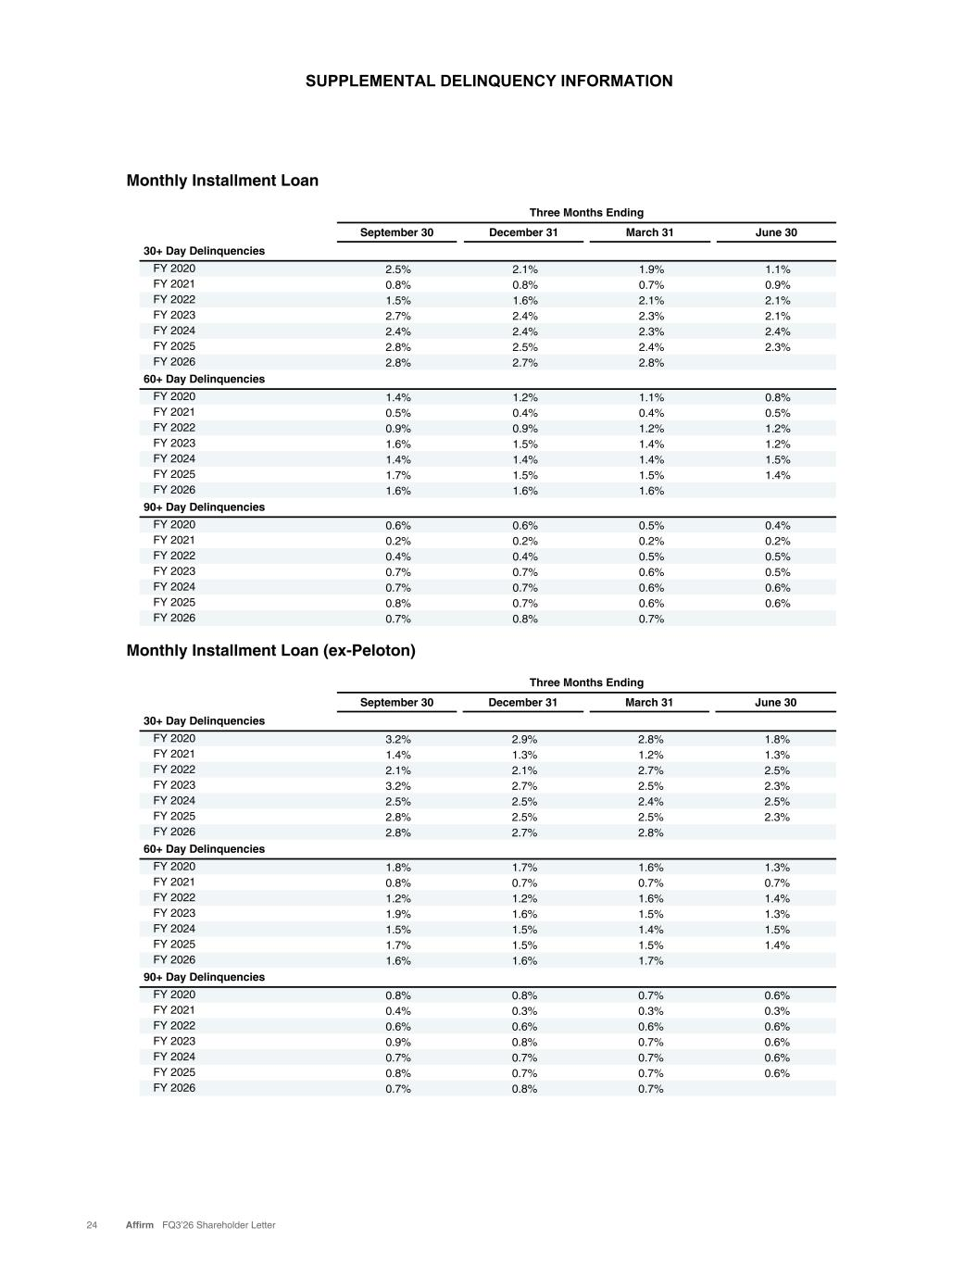
SUPPLEMENTAL DELINQUENCY INFORMATION 24 Affirm FQ3’26 Shareholder Letter Three Months Ending September 30 December 31 March 31 June 30 30+ Day Delinquencies FY 2020 2.5% 2.1% 1.9% 1.1% FY 2021 0.8% 0.8% 0.7% 0.9% FY 2022 1.5% 1.6% 2.1% 2.1% FY 2023 2.7% 2.4% 2.3% 2.1% FY 2024 2.4% 2.4% 2.3% 2.4% FY 2025 2.8% 2.5% 2.4% 2.3% FY 2026 2.8% 2.7% 2.8% 60+ Day Delinquencies FY 2020 1.4% 1.2% 1.1% 0.8% FY 2021 0.5% 0.4% 0.4% 0.5% FY 2022 0.9% 0.9% 1.2% 1.2% FY 2023 1.6% 1.5% 1.4% 1.2% FY 2024 1.4% 1.4% 1.4% 1.5% FY 2025 1.7% 1.5% 1.5% 1.4% FY 2026 1.6% 1.6% 1.6% 90+ Day Delinquencies FY 2020 0.6% 0.6% 0.5% 0.4% FY 2021 0.2% 0.2% 0.2% 0.2% FY 2022 0.4% 0.4% 0.5% 0.5% FY 2023 0.7% 0.7% 0.6% 0.5% FY 2024 0.7% 0.7% 0.6% 0.6% FY 2025 0.8% 0.7% 0.6% 0.6% FY 2026 0.7% 0.8% 0.7% Three Months Ending September 30 December 31 March 31 June 30 30+ Day Delinquencies FY 2020 3.2% 2.9% 2.8% 1.8% FY 2021 1.4% 1.3% 1.2% 1.3% FY 2022 2.1% 2.1% 2.7% 2.5% FY 2023 3.2% 2.7% 2.5% 2.3% FY 2024 2.5% 2.5% 2.4% 2.5% FY 2025 2.8% 2.5% 2.5% 2.3% FY 2026 2.8% 2.7% 2.8% 60+ Day Delinquencies FY 2020 1.8% 1.7% 1.6% 1.3% FY 2021 0.8% 0.7% 0.7% 0.7% FY 2022 1.2% 1.2% 1.6% 1.4% FY 2023 1.9% 1.6% 1.5% 1.3% FY 2024 1.5% 1.5% 1.4% 1.5% FY 2025 1.7% 1.5% 1.5% 1.4% FY 2026 1.6% 1.6% 1.7% 90+ Day Delinquencies FY 2020 0.8% 0.8% 0.7% 0.6% FY 2021 0.4% 0.3% 0.3% 0.3% FY 2022 0.6% 0.6% 0.6% 0.6% FY 2023 0.9% 0.8% 0.7% 0.6% FY 2024 0.7% 0.7% 0.7% 0.6% FY 2025 0.8% 0.7% 0.7% 0.6% FY 2026 0.7% 0.8% 0.7% Monthly Installment Loan (ex-Peloton) Monthly Installment Loan

